A Deep-Ensemble Framework for Multi-Stage Alzheimer's Disease Classification from Structural MRI Using EfficientNetV2-S and XGBoost

Arnav Verma¹, Vivek Verma², Kuljeet Singh^{2, *}
¹Department of Psychology, School of Psychological Sciences, Christ University, Delhi-NCR, 201003 – India
²Department of Computer Science, School of Sciences, Christ University, Delhi-NCR, 201003 – India

*Corresponding author at: Department of Computer Science, School of Sciences, Christ University, Delhi-NCR, 201003 – India (Email: kuljeet.singh@christuniversity.in, ORCID: 0000-0003-2592-8625)

ABSTRACT
Alzheimer’s Disease (AD) is the predominant cause of dementia, impacting more than 55 million people globally. However, identifying its early progression remains a significant clinical challenge. Conventional diagnostic techniques frequently struggle to identify the nuanced structural alterations in the brain linked to the progression from mild cognitive impairment to advanced dementia. This study establishes a high-precision, hybrid Artificial Intelligence framework that classifies MRI scans into four distinct categories: Non-Demented, Very Mild, Mild, and Moderate Demented. The proposed methodology integrates deep learning with ensemble machine learning using the Mendeley Alzheimer's Disease Dataset. It utilises EfficientNetV2-S, a sophisticated Convolutional Neural Network recognised for its parameter efficiency, to extract high-dimensional spatial features from preprocessed MRI scans. The features are optimised using Truncated Singular Value Decomposition (SVD) to minimise noise and computational complexity, and then classified using an XGBoost model, demonstrating enhanced performance compared to conventional Softmax layers on imbalanced datasets. Experimental findings confirm the model’s generalizability, achieving an overall test accuracy of 93% and macro-averaged precision, recall, and F1-score of 0.93. The hybrid architecture demonstrated strong sensitivity in detecting stage-specific disease patterns, with ROC-AUC values ranging from 0.91 to 0.96 across the four classes. Class-wise evaluation revealed particularly strong discrimination in Moderate Demented cases (precision = 1.00, recall = 1.00), while mild overlap between adjacent stages reflected clinically plausible structural similarity. The hybrid architecture demonstrated remarkable sensitivity in detecting early-stage disease patterns, as evidenced by elevated precision and F1-scores across all categories. This study concludes that the integration of deep feature extraction with gradient-boosting classifiers markedly improves stage-wise differentiation of AD based on structural MRI data, signifying a robust-disease staging framework that can allow for the future integration of more sensitive clinical markers for AD diagnosis.
Keywords: Alzheimer’s Disease, Artificial Intelligence, XGBoost, MRI, CNN
- INTRODUCTION
Alzheimer’s Disease (AD) has become the most common neurodegenerative disease in the world and is broadly categorized as familial (genetic) and sporadic (non-genetic) forms. A study conducted by Rostango [1] identify several potential causes of AD, which included familial cases are few, where only a small portion of people with AD have genetic mutations showcasing rare, dominant mutation in the APP, PSEN1, and PSEN2 genes; and additionally, the majority of late-onset AD (LOAD), which occur sporadically and later in life, is due to genetic risk factors, especially ApoE E4 allele of the of the apolipoprotein E gene, which is found in about 16% of the population with AD; similarly, poor diet, and low physical activity also contribute to a higher risk of AD; and conditions like diabetes, head injuries, chronic stress, and cerebrovascular disease are linked to increased likelihood of AD.
Patients with AD showcase neuronal loss, along with synaptic dysfunction, primarily due to amyloid plaque and tau accumulation, in regions of the amygdala, hippocampus, and pre-frontal cortex, which are associated with social behaviour and emotional regulation, and similarly, patients also display impairment in neurotransmitter systems, especially serotonin and dopamine, leading to further psychological symptoms [2]. Psychological conditions in relation to AD commonly include agitation, apathy, irritability, as well as sleep disorders and dysfunctional motor behaviour, as justified in the study conducted by Pinyopornpanish et al. [3], showcasing how these symptoms were prevalent in nearly all patients with AD and other forms of dementia, thus highlighting this link between cognitive decline along with neuropsychiatric disturbances, with a major symptom of AD being hallucinations as well. Other symptoms, such as depression, anxiety, elation, as well as appetite disturbances, were also prevalent amongst individuals with AD [4] as well as associated depressive symptoms of anhedonia, guilt, and psychotic delirium and paranoia as well [2]. Moreover, low mood, sense of helplessness, hopelessness (symptoms of depression/dysthymia), as well as decreased concern about daily activities, absence of motivation, and quick mood change (symptoms of apathy and emotional ability) were also found within patients of AD[5].
In general, the symptoms of Alzheimer’s are difficult to pinpoint due to individual differences within patients and types of Alzheimer's; however, typical symptoms, as listed in the study conducted by Bature et al. [6] include: memory decline, often appearing 2-3 years before the clinical diagnosis; depressed mood, often preceding the diagnosis by 37 months before diagnosis and corroborated with disinhibition, along with anxiety and apathy; agitation, irritability and changes in behaviour and personality; symptoms like disorientation in time and place and language impairment appear 29 months before diagnosis; specifically in rapidly progressive AD (RPAD), common symptoms observed were of hallucinations, seizures, myoclonus, and rigidity, on average appearing 26 months from first symptom.
Treatments for AD that are currently being used focus more on halting the progression of the disease and alleviating symptoms, rather than being the “cure” for them. In recent years, treatment has shifted away from the amyloid cascade hypothesis toward more targeted therapies, emphasizing drugs such as lecanemab and aducanumab, which target Amyloid-β (Aβ) plaques and Soluble Aβ protofibrils, respectively [7]. Donanemab has gained FDA approval, which also targets the removal of amyloid plaque from the brain; as a result, the clinical progression of AD seemingly reduces; however, safety is recommended due to side effects [8] While cognitive and memory decline continue to emerge as the primary diagnostic focus in AD research, NPS continue to emerge as important factors in influencing patients' quality of life. However, despite their high clinical importance, they are continually undervalued in biological/medical staging frameworks.
  - Current Scenario
A study done by Argiris et al. [9] on adults with family history of sporadic AD, who were cognitively impaired revealed interesting findings, in terms of tools for early detection of AD, classification of individuals on the basis of combined CSF biomarker patterns, rather than utilising amyloid-beta (Aβ) positivity as the sole indicator provided more accurate findings of AD changes b) three clusters were identified on the basis of the CSF biomarkers including C1, known as AD-like Cluster, showcased an increased concentration of p-tau and high amyloid (Aβ), as well as had significant loss of grey matter in hippocampus and high decline in executive function; C2, known as Neuroinflammation Cluster, which showed higher inflammatory (glial) markers, and lower Aβ levels; C3, known as Synaptic Cluster, characterised by high synaptic markers, low Aβ, but displayed overall better vascular health; Aβ-negative individuals still displayed AD-like patterns, and people who were Aβ-positive showcased a lack of them thus, suggesting that diagnosis based on amyloid positivity is more suitable for shorter term prognosis, rather than longer ones.
Recent studies on the current psychological profile of AD patients reflect an interesting link between neurobiological symptoms and their behavioural and psychological manifestations. A study conducted by Jenkins et al. [10] highlighted increases in symptoms of depression, both behavioural and physical, social withdrawal, as well as psychosis, with findings suggesting that the onset can manifest before overt cognitive decline, and how the key neurobiological markers of AD, namely amyloid-beta (Aβ) and tau accumulation, are linked to psychotic and depressive symptoms, restrictive behaviours, as well as dependent personality traits. Additionally, further studies showcase how higher anxiety within patients of AD is linked to alterations in structural brain changes influencing its functioning, particularly in areas like the limbic and temporal regions, as well as changed neurotransmission activity (particularly GlyRS activity), whereas depression is linked to damage in the temporal lobe, which can lead to impairments in the HPA-axis [11]. Exploring the links between depression, impairments in the HPA-axis, and damage in the temporal lobe can serve as important indicators of Alzheimer’s.
In terms of assessment, where the previous methods were more inefficient and often failed to detect subtle changes, A4 and LEARN studies reveal how plasma P-tau217 levels, along with tau PET imaging for tau buildup in the neocortex, are far more efficient in predicting decline in cognition and executive functioning, which occurs within 5 years, thus challenging the earlier held belief that it was a simple positive/negative cutoff, and exists more on a continuum [12]. These findings have potential advantages in terms of improving the timing and design of current pharmacological interventions for AD, namely donanemab and lecanemab.
Newer directions in terms of pathogenesis for AD were found as well, as revealed in the study conducted by Dash et al. [13] which focuses on how neuroprotection, the body’s natural proactive approach in preventing or limiting damage of the cells and defending the Central Nervous System against neurodegenerative disorders, is affected by oxidative stress, henceforth causing an imbalance between the body's natural defence mechanisms against disorders and the generation of reactive oxygen species, which in turn becomes highly essential for the pathogenesis of various neurological disorders, including Alzheimer’s. Another study conducted by Song et al. [14] corroborates these findings by displaying how oxidative stress, along with mitochondrial dysfunction, plays an important role in the onset of AD. Episodic memory impairment, particularly visuospatial delayed memory, was correlated with the accumulation of tau, thus highlighting the importance of identifying underlying cognitive changes along with pathological changes in the AD continuum [15].
  - Research Gaps in Treatment and Management of Neuropsychiatric Symptoms
Neuropsychiatric symptoms (NPS), though extremely prevalent within patients of AD, still showcase a lack of research in terms of efficacy and long-term interventions for several common symptoms like apathy, depression, agitation, anxiety, and more, where they are often not the primary therapeutic target, but rather as secondary outcomes. Studies, such as Pless et al. [16] showcase how the primary pharmacological treatment for depression continues to be Selective Serotonin Reuptake Inhibitors (SSRIs); however, large-scale meta-analyses showcased limited differences, in terms of efficacy, between SSRIs and placebos. Other studies highlight how the prevalent SSRIs, like sertraline and citalopram, have small effect sizes and showcase modest symptom improvement, all while reducing tolerability with inconsistent cognitive benefits, as well as a lack of clinical evidence to support their usage [17]. Although Vortioxetine, another SSRI used for depressive symptoms within patients of AD, showcased improvement in depressive symptoms within patients of AD, the study largely utilised a small sample, where improvements were not uniform and limited durability within one year, as a result of which generalisability could be harmed [18]
Apathy, which is the most common NPS within patients of AD, showcases other significant problems, with its primary pharmacological treatment being NMDA receptor antagonists and AChE inhibitors, which showcase either no or very little improvement in terms of efficacy relative to placebos [16]. The psychostimulant, methylphenidate, is a widely used drug for reducing symptoms of apathy within patients with AD, but a study conducted by Andrade [19] showcases how it showed statistically insignificant improvement in daily functioning, quality of life, and more relevant dimensions, and only modestly alleviated symptoms of apathy, thus raising a concern over its clinical significance. Moreover, SSRIs used for the treatment of apathy showcased a correlation with apathy syndrome, with patients being treated by SSRIs showing a higher rate of apathy syndrome relative to patients who were not prescribed it, thus further raising suspicion of it being a primary pharmacological choice for patients with AD and apathy symptoms [20]. Additionally, modafinil and bupropion, other pharmacological treatments for apathy, showcased limited clinical significance, with statistically insignificant improvements over the usage of placebos [21]. Other major drugs, like AChE inhibitors, serotonergic drugs like citalopram and sertraline, as well as semagecestat, showcased insignificant results, and some even worsened apathy within AD patients [22]. Limited efficacy within pharmacological treatment for apathy can be attributed to not keeping it as the primary target for these drugs, and often only kept as a secondary outcome.
Aggressive tendencies, paired with agitation, are also fairly common within patients of AD, especially among more elderly patients, and although non-pharmacological treatments are recommended they too show limited efficacy, whereas the pharmacological treatments, primarily anti-psychotics and benzodiazepines, which themselves have been linked with higher rate of dementia, and especially within patients with AD have been shown to cause higher rates of diabetes, hypertension, and longer stay in the ICU and in-hospital mortality [16], [23]. Other anti-psychotics, benzodiazepines, and anti-depressants show inconsistent and statistically insignificant clinical efficacy, all while showcasing symptoms like cardiac risks, higher rates of strokes, seizures, and short-term benefits [24].
Another common NPS among patients of AD is anxiety, whose treatments also have scarce clinical research, with existing ones highlighting possible limitations. The first line of treatment for anxiety continues to be SSRIs, SNRIs, and benzodiazepines; however, these don’t specifically target the neurobiological basis behind the onset of anxiety symptoms, particularly the GABAergic dysfunction, while still carrying risks of dependence, deficits in coordination, and cognitive impairment in elderly patients [25] A study conducted by Reyna et al. [26] on the efficacy of SSRIs for anxiety shows limited and inconsistent results, mainly due to the complex interaction between 5-HT and CRF systems and the HPA-axis, which reduces efficacy and only indirectly targets them, thus not focusing on the underlying biological basis of these symptoms. Long-term usage of benzodiazepines was also correlated with a reduction in brain volume, particularly the amygdala and hippocampus. Findings of no clear dose-response relationship paired with side effects of sedation, cognitive decline, and dependence further underscore the efficacy of benzodiazepines as a viable pharmacological treatment for anxiety symptoms within patients of both dementia and AD [27].
  - Neuropsychiatric (NPS) variations across AD stages
Neuropsychiatric symptoms (NPS) emerge as core symptomatic features of AD, whose intensity and severity tend to vary over disease severity stages of AD, i.e., Very Mild, Mild, and Moderately Demented. As highlighted in the study conducted by Pless et al. [16] in mild forms of AD, the most prevalent NPS are apathy, depression, and mild forms of anxiety, representing some deterioration of limbic and medial-temporal regions; however, as we move towards the moderate stages, the atrophy is more prevalent in frontal and temporo-parietal regions, leading to increased bouts of aggression, more delusions, psychosis, and agitation. The study conducted by Lyketsos & Peters. [28] showcased how NPS, including depression, apathy, anxiety, etc. affect nearly 98% of AD patients, with them displaying at least one NPS during the course of the disease, with clustering-patterns emerging alongside neurodegeneration: during MBI, symptoms like depression, anxiety, apathy, and more precede memory decline and as the cognitive decline worsens, they emerge more in the form of “agitation, psychotic, affective, and behavioural” clusters, and ultimately, during the later stages, as increased agitation, psychosis and apathy. This points towards how NPS “shift” and manifest as different forms during the stages of AD.
Additionally, these changes are not merely structural but also represent significant neurological alterations. The study conducted by Raphael [29] highlighted how, as AD progression rapidly continues, cortical atrophy extends to other subsequent regions of the brain, including ACC, OFC, tempoparietal regions, and more, leading to more complex psychotic manifestations of NPS, and due to the early presence of these NPS, there is a higher risk of conversion from MCI to AD. Another study by Ruthirakuhan et al. [30] highlights how in Very Mild/MCI stages, the symptoms are more milder and subtle, wherein they may not disrupt functioning significantly, including mild apathy, depression, and anxiety, wherein amyloid accumulation is quite low, however as both amyloid and tau accumulation increases, and we progress to the Mild stage, the symptoms are more noticeable and persistent, and begin to disrupt daily functioning, emerging in the form of more impulse dysfunctions, increase irritability and agitation, and more pronounced decrease in motivation, and finally in the Moderate stage, more sleep and appetite issues, along with higher forms of social disinhibitions, and aggression. Another study by Sharif et al. [31] examined the association between the emergence of NPS across various stages of AD, particularly linked to AD pathology, which increases in intensity and severity as we proceed from MCI towards the later stages. In conclusion, this view suggests the need of viewing NPS as important behavioural and symptomatic manifestations, wherein their presentation, intensity, severity seemingly evolve in correlation with the AD stages, wherein at the earlier stages, the symptoms are less pronounced and subtle, however as we progress towards the later stages, the effects are more noticeable, and directly influent patient quality of life, as well as speed of disease progression.
  - Our Contributions
The study is motivated to address the potential gaps in the treatment of AD with the primary focus on disease stage classification and a secondary focus on the future integration on NPS, such as depression, agitation, apathy, anxiety, and more, on enhancing diagnosis, where within the current methods show limited efficacy and only short-term benefits as they are often treated as secondary outcomes, and are not the primary therapeutic target. Effective management of NPS requires more proficient disease characterisation, as symptom severity and presentation vary across the different stages of AD progression. Even though literature showcases advancement in AI in its clinical application for AD patients, limitations exist, especially regarding unstructured, fragmented, homogenous, and often biased datasets, thus limiting their real-world application. The present study aims to:
- Propose the utilisation of an AI-based predictive framework, using robust MRI-driven AD stages data, for better AD disease-stage differentiation, helping detect each stage more robustly and accurately
- By focusing more on the improvement of the accuracy and reliability of disease staging, the model aims to support more precise risk assessment and better medical decision-making.
- While the model does not claim to directly predict NPS, it may provide for a future integration of NPS as clinically meaningful markers of AD, thus
- By improving AD treatment and detection, it focuses on allowing a more personal and patient-centred approach.

- REVIEW OF LITERATURE
Globally, the prevalence of AD has risen by 161% between 1990 to 2021, increasing from 21.8 million to 56.9 million cases, with the highest mortality rate being for the age group 65-69, highly concentrated in high-middle SDI countries like China and low-middle SDI countries, particularly in South Asia, such as India [32], making it the most common form of dementia in the world. The global economic burden of AD is substantial, with worldwide spending on AD treatment in 2019 estimated at $2.8 trillion, projected to rise sharply to $4.7 trillion by 2030, $8.5 trillion by 2040, and $16.9 trillion by 2050 [33]. Burden of AD, in terms of drug development, continue to be on the rise, where drugs already in late Phase 1 or beyond have a realistic chance of approval to be delivered to the public, highlighting the higher rate of failure thus, showcasing the overall major public health concern that it has become, where the total time period for development of AD drugs takes about 9 years, showcasing the slow pace of drug development [34]. This begs the question for more focus to be given on AD-based research, given its high prevalence and mortality rate and its ability to target an especially vulnerable population, i.e. older adults, where a shift from traditional AD diagnosis and early intervention needs to be fostered, to aid in treatment.
  - Emergence of Artificial Intelligence in AD Research
Recent years have showcased the efficacy of Artificial Intelligence as an effective predictive model, which can be used for early detection of various psychological symptoms, biomarkers, and onset, which can be helpful in treatment, alongside drug development as well. Meta-analysis conducted by Fernandes et al. [35] reveals how AI has started to be incorporated within the medical field, particularly the nursing field, for detection of behavioral and psychological symptoms of dementia (BPSD), where learning tools, such as natural language processing (NLP), digital health tools and machine learning has helped nurses assess and screen clinical symptoms within patients of both AD and dementia particularly by analysing facial expression, speech patterns and characteristics, as well as any physiological senses that can serve as early predictive markers for these symptoms, helping detect agitation and signs of emotional distress in real time. Additionally, a study conducted by Mahmud et al. [36] how an enhanced understanding of neural regions within the brain, affected by AD, can also be accurately achieved at a much higher rate, comparative to other prediction-based models, through the utilisation of CNS and saliency maps, all of which directly improves diagnosis and treatment ability of clinicians and physicians, along with how AI-based models can be used to detect AD patients after being trained on MRI scans [37], [38].
The ability of AI to integrate information from various neuroimaging data, provided through EEG, MRI, fMRI, PET, etc., as well as the utilization of and enhancement of current CNN models for accurate diagnosis and detection of AD [39], [40], [41], [42] as well as deep-learning models [43] and pre-computing techniques [44] alongside other clinical markers like age, sex, genetic markers, etc., have been utilised to increase the efficacy of its AI- based models for precise detection of onset, prognosis, as well as severity of various psychological symptoms associated with AD, where a study conducted by S.Song et al. [45] showcases an upward trend in literature about how NLP, CNNs, machine learning, and deep learning (ML and DL, respectively) have witnessed an increased usage, particularly in terms of identifying patterns associated with symptoms of various NPS associated with AD, such as anxiety, apathy, depression, and agitation, as well as other symptoms as well. Similarly, a study conducted by Jahan et al. [46] showcases how multimodal data within an RF classifier was able to display high levels of accuracy in the detection of five classifications within AD, which can be utilised to bring forth a highly accurate AI-based prediction model. Thus, evidence as given by recent literature showcases how AI can be effectively used for the detection of cognitive, mood, and psychological symptoms and patterns within patients of AD.
Other studies show how AD models can be utilised to predict the onset of symptoms within patients of AD, such as the study conducted by Vaghari et al. [47] which showcased how Prognostic and Predictive Model (PPM) which are fed on neurobiological multimodal AD datasets were found to have better precision and accuracy in detection of early cognitive and psychological symptoms within patients of AD, where by utilising biological barkers the Learning Model was able to differentiate patients who were clinically stable from those who were clinically declining, showcasing how leveraging AI into the treatment process can help in detection of various symptoms, both biological as well as psychological, at stages where interventions can prove to be the most efficient and where early detection can happen with accuracy rates much better than those ever provided by traditional methods of clinical diagnosis. A relatively older study on the application of AI-based models in AD research, as conducted by H. Li & Fan [48] displayed higher predictive accuracy, indicating which individuals are likely to transition from cognitive impairment to the onset of AD. This is further corroborated by a previous study on Kavitha et al. [49] using ML models for early-detection of onset of AD, displaying a relatively higher average accuracy of 83% when compared to other models, which enhances overall treatment and intervention strategy for patients, especially the older population, as well as Altwijri et al. [50] to accurately detect severity levels within AD patients.
Longitudinal studies conducted within patients of AD highlight more relevant usage of AI in AD treatment, wherein Statistical Modeling driven by AI was able to successfully reveal interactions between neuropsychiatric symptoms with biological markers, especially amyloid-β and tau accumulation, highlight how AI also showcases high efficacy in terms of detecting psychological symptoms and their interactions with the biomarkers underlying these symptoms within patients of AD, which can help in marking disease progression by utilising these oncoming neuropsychological symptoms as early pathological markers of AD, thus increasing prediction rate for detection of AD [51]. Other than neuroimaging data, AI models, particularly LLMs when fed on unstructured text data on symptoms about memory, mood, language, and other NPS were able to display better accuracy in diagnosis and distinction between patients of AD who were symptomatic and not symptomatic, especially of NPS like depression, agitation, apathy and more, and helped in tracking of changes in mental health, early detection, structural brain changes, as well as changes in mood and behaviour, highlighting the importance of utilising AI-based models in the field for prevention and treatment of NPS within AD patients [52].
Other studies which focus on how AI models can utilities in early detection and management of psychological symptoms within patients of AD highlight how they can effectively be used to detect NPS like agitation and depression, which enhance the overall life quality of people with both dementia and AD, by allowing not only for early detected but also formulation of effective intervention and treatment plans for them as well, whereas more symptoms, particularly hyperactivity, difficulty in sleep, psychotic symptoms, etc. can be detected and effectively managed with the help of AI models as well [53], [54] whereas a more recent study, which was conducted by Kang et al. [55] showcase the benefits of utilising AI models in terms of management of psychological symptoms, pertaining to depression and mood, which showed significant improvements within the patients, highlighting its scope, not only as an early predictive model, but also as an active therapeutic and management intervention as well.
  - Challenges in Clinical Application of AI Models
Numerous studies on the use of AI models in the treatment of AD highlight their advantages, particularly in early diagnosis, the development of intervention plans, and symptom management. However, application of these models comes with their own set of challenges, especially in terms of getting efficient and high-quality data sets, a problem which was highlighted in the study conducted by Mandal et al. [56] wherein a comprehensive review of existing clinical datasets revealed how many of them are often synthetic, scattered, where many are inaccessible and are often under-documented, as well as lacking in cultural, linguistic, and socio-economic diversity, causing the reliability of AI-models to be harmed. Other studies, which delve more into the ethical challenges of using datasets, about privacy and bias focus on how existence of data sets of specific populations might be limited, where certain groups are more under-represented which may cause the suggestions and treatments recommended by the AI model to be unsuitable or non-specific, and models which are fed on less diversified data can lead to unfairness in terms of access to health care, certain treatment plans, and diagnosis, further highlighting the need to have more diversified data, and additionally integrating complex healthcare procedures and navigation regulatory difficulties prove to be another challenge that AI can face in relation to more therapeutic management of psychological symptoms as limited professionals are trained to use AI-based models ethically and efficiently to gain the maximum possible results [57].
Regarding these issues, more recent comprehensive analyses, such as those conducted by further Fanarioti & Karpouzis [58] further confirm these concerns by categorising gaps in clinical application of AI models, wherein firstly, being fed to biased, narrow, and often unrepresentative data where various groups, based on language, age, sex, etc. are excluded lead to inaccuracies in diagnosis and biased or generalised strategies or intervention plans, secondly, informed consent remains a grey area in the using of dataset comprising of sensitive biological, psychological, and perhaps emotional data, where access to these are gained without the knowledge of the individual and additionally, lack of consistent overwatch of these AI models, by a global governing body, raises concern on transparency and fairness in their application in the therapeutic setting and lack of training on the side of medical professionals and nursing staff further hinder the ability to use these tools more efficiently and responsibly.
About applications in the field, AI-models usually remain stagnant which hinders their ability to evolve as the clientele changes, limiting their ability to account for individual differences in symptoms and adaptability, while also not being able to account for patient feedback, whereas the high cost associated with data collection once again leads to more generalised and biased data sets, restricting its real-world application, and additionally, AI’s own limitations in accurately understanding and modeling biomarkers for various psychological symptoms and how they intervene and interact with multiple biological and neurological symptoms further raise concerns over their usage in the clinical setting and adding onto these the human limitations, especially their own biases and inequalities, further hamper efficient and non-biased utilisation of AI-based models in treatment and intervention [59]. Other models, such as LLMs and Machine Learning (ML) models, also come with their own sets of challenges, as highlighted in the study conducted by Hua et al. [60] wherein these models are often not utilised much in clinical setting beyond early-stages primarily due to non-standardised frameworks of evaluation for these models, as well as usage of uncurated, biased data sets that is fed to them leading potentially to harmful or misleading advice, thus highlighting potential risks over sensitivity and a need for more standardised models if they need to be more efficient in clinical application.
AI’s application in treatment, intervention, and early detection of NPS within AD patients comes with its own set of challenges, as they were highlighted in the study conducted by Mohsen [61] which focused how current application of AI models have showcased difficulties in reproducibility, with inconsistent findings across multiple studies and population, thus causing standardisation issues, while also having problems in early detection of both AD and MCI, as well their NPS, primarily due to biomarkers associated with their onset being very subtle and the data on them being very limited, and the available datasets on AD being very scattered, having small sizes, and often containing incomplete, and nosy data which makes detection an extremely challenging task, and additionally AI-models have showcased good results only in experimental setting but when it comes to application in the real world, very few models have showcased actual clinical validity in their application, highlighting how these tools need to be fed on more larger, representative data, while also showing better accuracy and higher rates of validated and reliable in diagnosis and early detection, in order to increase both patient trusts as well as that of the practitioner/clinician. Other studies, such as those conducted by Jasodanand et al. [62] further talking about the concerns of having a fragmented, missing, and heterogeneous ADNI dataset which compromises the real-word clinical application of AI-models, wherein patients with atypical disorders or comorbidities are often excluded, differences in imaging, device algorithms, and technical inconsistencies further complicating the issue, where both advanced and traditional AI models were requiring more efficient, data sets, in terms of size, more completed, and more homogenous data set to function more efficiently and deliver reliable and consistent results.
- RESEARCH METHODOLOGY
The present study aims to establish a Hybrid Deep-Classical AI framework for the differentiation between AD disease stages, while also enabling future NPS integration, by utilising structural MRI scans to improve early intervention and detection of AD. The model, by allowing for improved disease-stage stratification, will thus help clinicians make more informed medical decision-making and allow for a more patient-centred approach.
  - Dataset Description
This research utilizes the Alzheimer’s Disease MRI dataset sourced from Mendeley Data (https://data.mendeley.com/datasets/ch87yswbz4/1). The dataset comprises structural magnetic resonance imaging (MRI) brain scans classified into four diagnostic categories: Non-Demented (ND), Very Mild Demented (VMD), Mild Demented (MD), and Moderate Demented (MOD). The dataset contains labeled brain MRI images that illustrate the successive phases of Alzheimer’s disease, facilitating supervised learning for multi-class categorization. All MRI images were reduced to 224 × 224 pixels and converted to RGB format to comply with the input specifications of the EfficientNetV2-S architecture. To enhance generalisation and alleviate overfitting, prevalent issues in medical imaging tasks, data augmentation approaches were utilised only on the training and validation sets. The augmentation strategies encompassed spatial modifications, including rotation, horizontal flipping, scaling, and normalizing. The augmentation approach artificially enhanced the diversity of the training samples while maintaining clinically pertinent characteristics.
The dataset was divided using stratified sampling into 70% for training, 10% for validation, and 20% for testing subsets. The test set consisted exclusively of authentic, non-augmented MRI images from the dataset, ensuring that model evaluation accurately reflects real-world performance without the influence of artificial alterations on the results.
  - Problem Formulation
The objective of this research is to create an intelligent system that can categorize MRI brain images into one of four stages of Alzheimer's disease. This problem is modelled mathematically as a multi-class classification task, to learn a mapping function:
$$fθ​:X→Y (1)$$
As shown in Equation (1), where $X=\{x1,x2,…,xn\}$ is the set of MRI images that are input and $Y=\{y1,y2,…,yn\}$ is the set of MRI images that are output. $Y = \{y1, y2, …, yn\}, with yi ∈ \{0, 1, 2, 3\}$, shows the labels for each stage of Alzheimer's disease. The model $f_{0}$ is parameterized by weights, which are optimized during the training process to minimize the categorical cross-entropy loss:
$$L(θ)=-\frac{1}{N}\sum_{i=1}^{N}{\sum_{c=1}^{C}{y_{i,c}log({{\hat{y}}_{i,c})}}} (2)$$
As shown in Equation (2), where $C=4$ is the number of classes, and $y_{i,c}$, is the correct label, and ${\hat{y}}_{i,c}$ is the predicted chance of class $c$. The goal is to make $L(θ)$ as small as possible while making the accuracy of the classification and the area under the ROC curve (AUC) as large as possible.
  - Methods Used
The proposed method combines the frameworks of deep and classical machine learning to leverage the strengths of both methodologies. To extract deep features, EfficientNetV2-S, a state-of-the-art convolutional neural network pre-trained on the ImageNet dataset, was first used. EfficientNetV2-S was selected because of the network depth, width, and resolution are optimized to enable it to scale efficiently to compute without accuracy loss. To optimise the trained CNN on Alzheimer MRI data, a new fully connected layer with four output neurons, corresponding to the four diagnostic classes, was substituted for the original classification head. The CNN generates a high-dimensional feature representation of every MRI image.
The following step involved minimising the computational cost of these features and increasing their discriminative power using Truncated Singular Value Decomposition (TruncatedSVD) of the extracted feature vectors. The reduced feature space was the most informative, while minimising noise and redundancy. Lastly, the XGBoost classifier, an algorithm based on gradient-boosted decision trees, was used as the final classification stage. The reason of using XGBoost was its strength, interpretability, and ability to handle nonlinear relationships. The evaluation metrics used to assess the model’s performance were accuracy, precision, recall, F1-score, and the area under the receiver operating characteristic (ROC) curve (ROC-AUC). Moreover, the model performance and features separability were interpreted with the help of the visualisation tools, including confusion matrices, ROC curves, kernel density plots, and t-distributed stochastic neighbour embeddings (t-SNE) projections.
  - Proposed Methodology

- Training Phase
The training process was conducted using the augmented subset of the Alzheimer's MRI dataset to enhance model generalization and robustness, as shown in Figure 1. Following a stratified division of the dataset into 70 percent training, 10 percent validation, and 20 percent testing subsets, data augmentation methods were implemented only to the training and validation subsets. Some of these augmentation operations were spatial operations, like resizing, random rotation, and horizontal flipping, in addition to intensity normalization. Augmentation aimed to artificially enforce variability in the data, approximate anatomical variations, and reduce overfitting, especially since medical imaging data are particularly sensitive to changes in distribution. Representation of the augmented training dataset can be as follows:
$${\tilde{D}}_{train}​={\{(T(x_{i}​),y_{i}​)\}}_{i=1}^{N} (3)$$
In Equation (3), where T(.) refers to the augmentation transformation function. Similar transformations are also done to the validation set (deterministic normalisation) to check the generalization performance as they change slightly.
As a deep feature extractor, EfficientNetV2-S, which is trained on ImageNet, was utilized. Its last fully connected classification layer was substituted with four neuron output layer that represents the four stages of Alzheimer's. The network was trained with 10 epochs and the Adam optimizer with a learning rate of $1 x {10}^{-4}$ and a batch size of 32. The objective of the optimization was to have the minimal categorical cross-entropy loss function. Forward propagation was carried out during every epoch to calculate the predicted probabilities, and then backpropagation was used to update the network parameters. The augmented validation data was used to validate after every epoch of training. The accuracy of validation and loss was observed to determine convergence behavior and eliminate overfitting. The training curves showed a stable convergence, and the generalization difference between training and validation performance was small, which shows that regularization with the help of augmentation was effective. After CNN training, the completely trained network was dropped to a feature extractor by taking out the last classification layer. From the penultimate layer, every training image augmented was sent through the feature extraction module to come up with a 1280-dimensional deep feature vector. Truncated Singular Value Decomposition (TruncatedSVD) was used to reduce the feature redundancy and the number of calculations by projecting the 1280-dimensional embeddings into a 100-dimensional subspace. The feature vectors were reduced and then trained on an XGBoost classifier with the multi-class logarithmic loss objective function (mlogloss). The XGBoost model was built by the repeated construction of boosted decision trees that were constructed with the view of decreasing the classification error on the smaller feature representations.
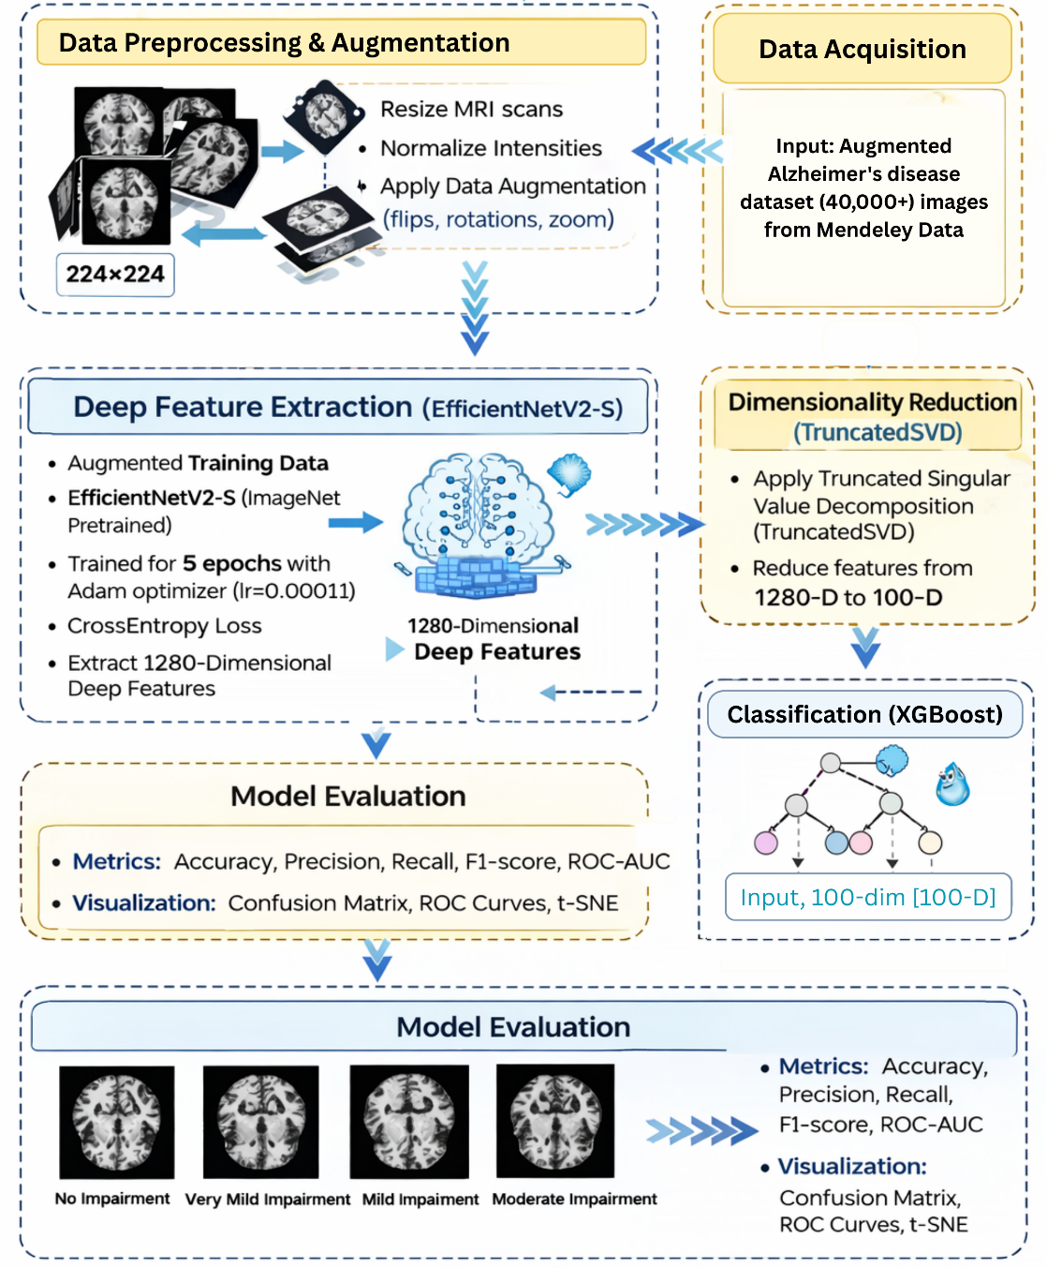
Figure 1: Proposed Hybrid Methodology for Alzheimer’s Disease Stage Classification Using EfficientNetV2-S and XGBoost.
- Testing Phase
The testing was done on the original images (non-augmented MRI images) of the dataset only to make sure that it is an unbiased and clinically feasible performance measure, as shown in Figure 5. The test data were not augmented or subjected to any synthetic transformation; hence, the test data were distributed in a natural way of MRI scans.
To have an objective assessment, however, the test data is stated as:
$${\tilde{D}}_{test}​={\{(x_{j}​,y_{j})\}}_{j=1}^{M} (4)$$
In Equation (4), where $x_{j}$ is the initial, non-augmented MRI images. This will ensure that the reported performance measures are a true diagnostic of the model within realistic clinical conditions.
The images used in each test were initially rescaled and standardized to the CNN input standards, though not randomly transformed. EfficientNetV2-S, trained as an efficient feature extractor, was subsequently employed to generate deep feature embeddings of 1280 dimensions on every sample in the test set. These embeddings were then mapped into the 100-dimensional subspace as had been trained to the TruncatedSVD transformation to be consistent between training and testing feature representations. The trained XGBoost model was again used on the pruned test set features to produce class probability estimates and final-stage estimates. The evaluations were conducted by comparing predicted labels to ground truth annotations to calculate metrics such as accuracy, precision, recall, F1-score, and ROC-AUC.
Due to the fact that the testing was conducted on original MRI images and not augmented samples, the reported results represent the actual generalization of the proposed hybrid EfficientNetV2-S + XGBoost framework in actual clinical settings. The results of the performance indicate that augmented data training was effective in increasing robustness without reducing high predictive performance on unseen real-world data.
  - Proposed Algorithm
The operational workflow of the proposed hybrid categorization system is formally described in algorithmic format, as shown in Algorithm (1). The approach mathematically combines deep convolutional feature extraction, dimensionality reduction, and gradient-boosted decision tree classification into a cohesive pipeline. The process initiates with the development of augmented training data to improve robustness, followed by feature learning with EfficientNetV2-S. The high-dimensional embeddings are then converted into a compact representation by Truncated Singular Value Decomposition, minimizing redundancy while maintaining discriminative information. An ensemble-based XGBoost classifier systematically refines a regularized objective function to execute multi-class prediction. This mathematical formulation delineates the sequential optimization process, from input data representation to final class assignment, ensuring clarity, reproducibility, and theoretical rigor of the proposed model.
Algorithm 1: Mathematical representation of the proposed methodology.
Input: MRI dataset D with classes {NI, VMI, MI, MOD}
Output: Predicted stage ${\hat{y}}_{i}$ ∈ {NI, VMI, MI, MOD}

- Feature Extraction using EfficientNetV2-S:
$$ϕ(x_{i})=f_{CNN}(x_{i};θ)∈ R^{1280}$$
Where $f_{CNN}$ is the CNN function parameterized by $θ$.

- Dimensionality Reduction using TruncatedSVD:

$$z_{i}=W^{T}ϕ(x_{i}), W∈R^{1280x100}$$

where $W$ is the projection matrix retaining top singular components.

- Classification using XGBoost:

For each boosting round $t=1,2,…,T$:

$$F_{t}\left(x_{i}\right)=F_{t-1}\left(x_{i}\right)+η.h_{t}(x_{i})$$

where $F_{t}\left(x_{i}\right)$ is the ensemble prediction, $h_{t}(x_{i})$ is the weak learner, and $η$ is the learning rate.

The final prediction is given by:

$${\hat{y}}_{i}=arg \max_{c∈\{0,1,2,3\}}{P(y_{i}=c | z_{i})}$$

- Loss Minimization Objective:

$$L=-\sum_{i=1}^{N}{\sum_{c=1}^{4}{y_{i,c}\log{{\hat{y}}_{i,c}+⋋{\left\|θ\right\|}_{2}^{2}}}}$$

where $⋋$ is the regularization parameter preventing overfitting.
- RESULTS
  - Evaluation Metrics
The performance of the proposed system was assessed using five key metrics: accuracy, precision, recall, F1-score, and area under the ROC curve (AUC). The first is accuracy, which is used to evaluate the correctness of the predictions as a whole, and the second is precision and recall, which is used to determine the ability of a model to correctly identify the positive predictions as well as to recall relevant instances respectively. The F1-score provides a harmonic mean of the precision and recall, which is the balance between false positives and false negatives. The ROC-AUC measure tests the ability of the classifier to discriminate at different threshold values and thus it is an important metric used to test medical diagnostic systems.
  - Implementation Details
All experiments were conducted using Python 3.10, with PyTorch 2.0 serving as the primary deep learning framework. Model development and training were carried out on a system, powered by an 11th Gen Intel(R) Core (TM) i5-1135G7 CPU @ 2.40GHz, coupled with 12 GB RAM. The system featured a 233 GB NVMe SSD and a 932 GB HDD for data storage, and computations were supported by NVIDIA GeForce MX350 (2 GB VRAM) alongside Intel Iris Xe Graphics (128 MB). The machine operated on a 64-bit Windows OS. The batch size was set to 32, and the input image dimensions were fixed at 224×224 pixels. The Adam optimizer was used with a learning rate of $1 x {10}^{-4}$, and the model was trained for 10 epochs. The feature vectors extracted from the CNN were reduced to 100 components using TruncatedSVD. The final classification was performed using XGBoost with “mlogloss” as the evaluation metric and default regularization parameters. Data visualization, including confusion matrices, ROC curves, KDE plots, and t-SNE visualizations, was conducted using Matplotlib and Seaborn libraries.
  - Training and Testing Results
The CNN has shown consistent convergence during training on augmented data, with training accuracy around 95% and validation accuracy around 92%. The augmentation helped avoid overfitting, as evidenced by the small difference between the training and validation performance curves. To evaluate this, the trained feature extractor and the XGBoost classifier were tested only on original, non-augmented MRI images. This type of testing approach ensures that performance metrics are based on real-world applicability rather than idealised scenarios. The hybrid model achieved test accuracies of 90-93%, with ROC-AUCs of 0.91-0.96 across the four classes.
Table 1: Class-wise performance metrics of the proposed model evaluated on the original test dataset.
Class | Precision | Recall | F1-Score | Support
No Impairment | 0.89 | 0.87 | 0.88 | 392
Very Mild Impairment | 0.89 | 0.87 | 0.88 | 392
Mild Impairment | 0.93 | 0.97 | 0.95 | 392
Moderate Impairment | 1.00 | 1.00 | 1.00 | 292
Macro Average | 0.93 | 0.93 | 0.93 | 1396
Weighted Average | 0.92 | 0.93 | 0.93 | 1396
Overall Accuracy | - | - | 0.93 | 1396

As shown in Figure 2, the confusion matrix shows that the overall classification performance is very good, with most of the predictions lining up along the main diagonal. The model accurately categorized 382 MD, 292 MOD, 278 ND, and 340 VMD samples. Moderate Demented cases were identified with flawless class separation, exhibiting no misclassification. There is some confusion, mostly between disease stages that are next to each other, like ND and VMD, and ND and MD. This makes sense from a clinical point of view because early-stage Alzheimer's progression has some similar structural characteristics. Overall, the matrix shows that it can tell the difference between the four classes very well and make predictions that are fair across all four classes.
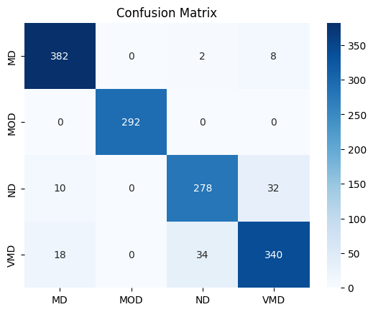
Figure 2: Confusion Matrix of the Suggested EfficientNetV2-S + XGBoost Model for Classifying Alzheimer's Stages.
Figure (3A) Receiver Operating Characteristic (ROC) curves of the four classes of Alzheimer's disease that assess the discriminative ability of the proposed EfficientNetV2-S + XGBoost model. The model has excellent classification performance in terms of classification, with the value of Area under the Curve (AUC) of 1.00 for Class 0 (MD), 1.00 for Class 1 (MOD), 0.97 for Class 2 (ND), and 0.98 for Class 3 (VMD). The curves are not far away from the top-left corner of the graph, which implies that there are high true positive rates (TPR) and low false positive rates (FPR), thus showing good sensitivity and specificity of all the classes. Figure (3B) Kernel Density Estimation (KDE) of the estimated class probabilities. The two modes in every class suggest certain predictions, with a concentrated probability mass at 0 and 1. This separation implies that the model delivers well-calibrated predictions, whereby there is a lot of confidence in accurate predictions and low-confidence between classes. The results of the ROC and KDE analyses together demonstrate the robustness, discriminative strength, and probabilistic reliability of the proposed hybrid classification framework.
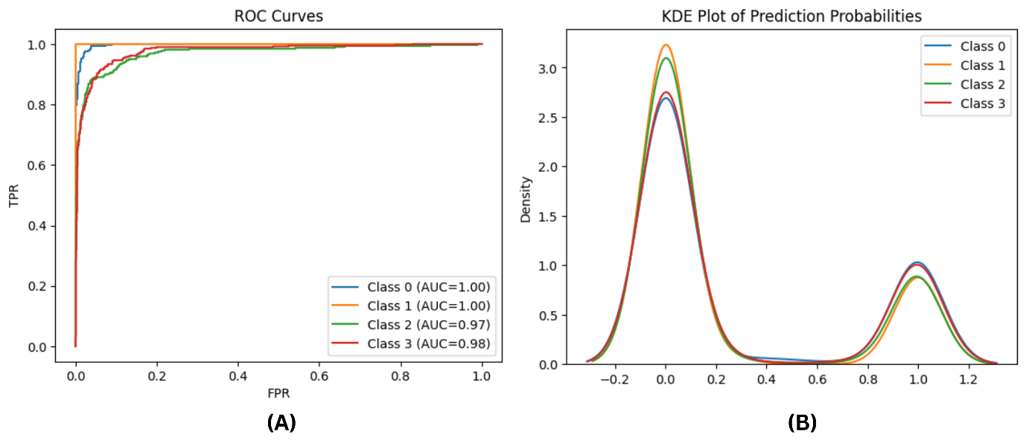
Figure 3: (A)Receiver Operating Characteristic (ROC) Curves and (B)Kernel Density Estimation (KDE) of Prediction Probabilities for the Proposed Model.
The Figure (4) represents a two-dimensional t‑distributed stochastic neighbour embedding (t‑SNE) project of high-dimensional deep feature representations of the EfficientNetV2 -S model before final classification. The plot is described by a point that is about the MRI sample, and it is coloured based on the label of the classes: Class 0 (MD), Class 1 (MOD), Class 2 (ND), and Class 3 (VMD). The visualization Figure (4) shows that there is strong feature discriminability of the convolutional neural network as it clearly clustered delineation of the four stages of Alzheimer disease. It is important to note that the Moderate Demented (Class 1) cluster is highly distinct because of the differences with the other classes, which implies unique structural patterns regarding the late disease stages. There is slight overlap between successive stages e.g. Mild Demented and Very Mild Demented which is within clinical anticipations due to the slow pathological changes. In general, the t-SNE projection allows us to conclude that the 1280-dimensional embeddings obtained contain meaningful structural representations of Alzheimer severity, which are useful to downstream classify using the XGBoost model.
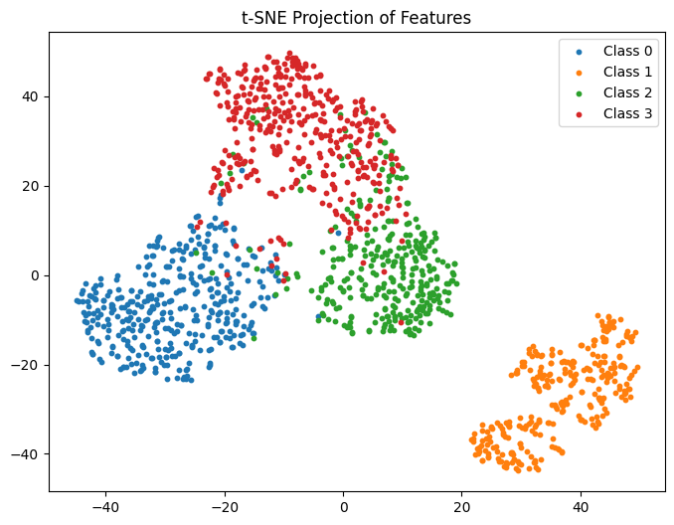
Figure 4: t-SNE Projection of Extracted Deep Features for Alzheimer’s Stage Classification.

Figure 5 presents a sample test of MRI that proved to be properly recognized by the proposed EfficientNetV2-S with XGBoost framework. The ground-truth label, predicted label, and the confidence score are shown in each image. All the correct identifications of cases include Moderate Demented, Very Mild Demented, Non-Demented, and Mild Demented with high confidence values of 0.99 to 1.00. These illustrations show that the model has good predictive reliability and high certainty in each of the four stages of Alzheimer's. The value of the scores near 1.00 depicts that the classifier puts a prevailing mass of probability in the correct classes, which can be seen as clearly distinct feature representations and strong decision boundaries. The similar results between both the initial and late phases also confirm the suitability of the hybrid deep-feature extraction and gradient-boosting classification model to stagewise detection of Alzheimer's disease.

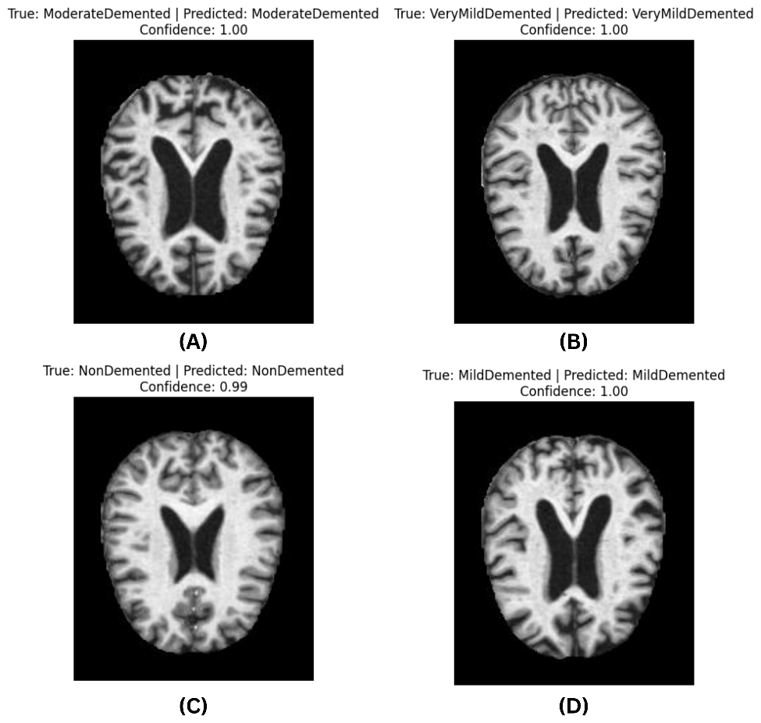
Figure 5: Predicted Correctly Accurate Predictions of the Proposed Alzheimer stage classification model at confidence scores.
  - Comparison with Existing Methodologies
Compared with recent MRI-based AD classification studies, the present study addresses several limitations and is better suited to real-world applications. A study conducted by Mousavi et al. [63] displayed very high accuracy values, approaching 99%, however was limited mainly to accuracy and class-wise precision and recall. While these values have their own set of applicability in the real-world, it failed to capture the ability of the model to successfully differentiability across decision threshold, what the reliability values were for the predicted probabilities, and solely relying on CNN end-to-end learning, The present study adjusts for this gap by utilising a hybrid CNN model, and using ROC-AUC analysis to successfully showcase the ability of the model to discriminate across thresholds, which is highly relevant in medical/clinical settings. Similarly, the use of KDE of predicted probabilities and t-SNE projections to confirm that the model could distinguish between and meaningfully capture the subtle structural changes across AD stages further enhance methodological rigour of the study.
Similarly, another study by El-Assy et al. [64] displayed overall high accuracy and recall rates across the three, four, and five-way classifications of AD, going apart from the traditional binomial or three-way categorisation, however he the applicability in real-world setting was reduced primarily due to small dataset size, manually chosen filter sizes which will have difficulty in detecting subtle structural changes across the AD stages, with no probability calibration or feature-space validation being performed, which further hurt real-world applicability and usage in medical settings. To cover these methodological gaps, the present study incorporated a dataset of over 40,000 + MRI images for better anatomical variability, improved discrimination, and generalisation. While the previous study used ADASYN to reduce imbalance, the present study relied on data augmentation on training and validation, along with a stratified sampling, to prevent local densities. Additionally, instead of relying on manually designed filters, the present study incorporated trained architectures (EfficientNetV2-S, Truncated SVD, and XGBoost) to allow for better interpretation and improved filters. Utilisation of t-SNE and KDE analysis, instead of using only Grad-CAM to show attention maps as the previous paper did, further improves our model and resultant findings.
The study conducted by Wen et al. [65] utilised a CNN model to extract the structural features of the brain via MRI scans, and even demonstrated good accuracy, the generalisation and applicability were reduced mainly because of the small dataset, insufficient augmentation of the data, and overreliance on pure CNN-models. The small dataset can lead to overfitting, and since the structural changes between different AD stages are very subtle, it can reduce its clinical application as well. Additionally, minimal augmentation of data further reduced the applicability. To counter these limitations, the present study used a large dataset (40,000+ images), along with augmentation of data during training and validation, and an overall Hybrid model, effectively using trained architectures, and demonstrating high accuracy (90-93%) across all 4 stages of AD, namely ND, VMD, MD, and MOD, which the previous study lacked, and further improved clinical application, as its more appropriate in terms of AD treatment and detection. Utilising ROC-AUC analysis (0.91-0.96) further highlights the high differentiating abilities of the model between the different AD stages, showcasing better real-world and clinical applicability.
A study by AlSaeed & Omar [66] utilised datasets from ADNI and MIRIAD, and displayed high levels of accuracy, exceeding 99%; however, the model performed a binary categorisation (AD vs NC), with the study considering that multiple scans from the same patients are independent MRI scans, which can lead to an inflated performance. To counter the methodological errors, the present study utilised a large, heterogeneous dataset divided into four classifications to signify the disease progressing during AD, implementing a hybrid model with trained architecture (EfficientNetV2-S, TruncatedSVD, and XGBoost) for better extraction and classification. Another limitation of the previous study was the lack of augmentation in the training and validation phase, which the present study incorporated for improved methodological rigour. Such implementations allow for a model more suited for medical settings. Similarly, another study conducted by Qiu et al. [67] displayed very strong accuracy levels and external validation; it also relied on binary classification and cognitive scoring via MMSE assessments, along with employing 3D MRI volumes and FCN models, which increase the computational cost and make it difficult to apply in real-world settings. In response, the present study tracked the stage-wise progression of AD by utilising a 40,000+ MRI images dataset divided into a 4-stage classification, and employing trained architectures to reduce computational cost, and by completely relying on imaging data, it allows the results to be more objective and cleaner.
Focusing on more recent AI-based models utilising structural MRI images for AD diagnosis and assessment also reveals important differences in methodological rigour and overall approach. For instance, the study conducted by Vecchio et al. [68] used a longitudinal analysis and acceptable accuracy, making it highly relevant for clinical applications. However, the study employed a relatively smaller dataset (104 patients), a binomial classification, with slower segmentation and relatively lower AUC (approx. 0.85) The present study, as a result, utilised a relatively larger dataset (40,000+ images) to improve clinical relevance and generalisation, as well as a 4-class classification to better capture the nuances of structural changes during AD prognosis, with faster segmentation to improve scalability and practicality, and high AUC (0.99-1.0) allowing for better differentiation between stages of AD, which allowed for more clinical relevance. Another paper by Yang et al. [69] utilised an SIT model to focus more on a biological approach towards the detection of AD hemispheric asymmetry based on 3D sMRI and a CNN-Transformer model, displaying good accuracy and differentiation (Accuracy = ~92%, AUC = ~0.92). However, the model utilised a small dataset, wherein the computational architecture used limited scalability and generalisation. In contrast, the present study utilised a Hybrid XGBoost and EfficientNetV2S model, larger dataset of AD patients (40,000 + structural MRI images), which allowed for augmentation of dataset during training and validation, more clearer optimisation objective, and higher clinical relevance as the study incorporated a stage-wise differentiation, while the previous study mainly focused between AD vs CN vs MCI, with higher accuracy and differentiation (Accuracy = ~93%, AUC = 0.99-1.00).
A study by Aghajanian et al. [70] focused on a longitudinal study, focusing on progression from MCI to AD, utilising the ADNI dataset, and LSTM architectures. Though the study displayed unique and advanced modelling techniques and promising results, the study required a high methodological rigour, as multiple visits are needed due to the study needing 3 MRI scans within a constrained window, which reduced employability in real-world settings due to the high computational cost. Additionally, using highly complex architectures (3D CNN, LSTM, and Cox model) can lead to overfitting, and focus more on progression, rather than stage-wise disease progression, which has limited clinical applicability. The present study, therefore, worked on a hybrid deep-classical model which allowed for more improved balance and stability, employed the use of single cross-cultural scans to allow for more scalability, and focused on a 4-class classification (ND, VMD, MD, MOD) that allows for more immediate diagnosis and disease tracking. The study by Slimi et al. [71] also displayed extremely high accuracy (~99%) but displayed some methodological weaknesses, with the primary one being the conversion of 3D structural MRI scans into 2D slices, which can increase chances of data leakage, while also performing augmentation at an extremely small cohort (~190 patients), and no feature space control. In contrast, the present study performed augmentation at train/val stages, and by performing a 70/10/20 split, which allowed for more generalisation and plausible results, while also employing trained architectures to balance variance and reduce redundancy.

References | Year | Focus | Model, Performance | Dataset | Limitations | Present Model Performance | Comparison with Present Model | Strengths of Current Model
[63] | 2025 | AD | CNN; Overall Acc = 0.99, Prec/Rec/F1 = 0.99 | Multi-Disease MRI Dataset (~6735 MRI scans) | Small dataset, only provides accuracy, recall, and precision, along with no probability reliability + threshold discrimination | Training Accuracy = 95%, Validation Accuracy = 92%, Testing Accuracy = 93%, ROC-AUC = 0.91-0.96, Precision = 1.00, Recall = 1.00, AUC = 0.97-1.00, CI = 0.99-1.00 F1 = 0.88-1.00 | Large Dataset (40,000+ scans), Uses a Hybrid-CNN model, gives ROC-AUC, t-SNE, KDE analysis, and better projections for feature analysis | Better Discrimination ability, improve reliability in medical settings
[64] | 2024 | AD | CNN; Proposed CNN: Acc = 99.3–99.6%, AUC = 0.97–1.00) | ADNI and OASIS (30,000MRI scans) | Manually chosen filter size, no probability calibration, no feature validation, reducing real-world applicability, possible local densities, uses a 90/10 split only for train/testing | Training Accuracy = 95%, Validation Accuracy = 92%, Testing Accuracy = 93%, ROC-AUC = 0.91-0.96, Precision = 1.00, Recall = 1.00, AUC = 0.97-1.00, CI = 0.99-1.00 F1 = 0.88-1.00 | Large dataset (40,000+ scans), data augmentation on training and validation, used trained architectures instead of manually designed filters, uses 70/10/20 split for train/val/testing | Improve anatomical variability, better generalization and discrimination capacity,data augmentation on train/val
[65] | 2020 | AD | CNN; Overall Accuracy – CNN = 0.82 - 0.89, SVM = 0.87-0.88 | ADNI, AIBL, OASIS | Overreliance on purely CNN-models, insufficient augmentation of data, small dataset, risk of overfitting | Training Accuracy = 95%, Validation Accuracy = 92%, Testing Accuracy = 93%, ROC-AUC = 0.91-0.96, Precision = 1.00, Recall = 1.00, AUC = 0.97-1.00, CI = 0.99-1.00 F1 = 0.88-1.00 | Trained architectures, augmentation on train/val, large dataset (40,000+), uses Hybrid model | Better real world and clinical applicability, better generalization and discrimination capacity
[66] | 2022 | AD | CNN, Overall Accuracy = 85.7% - 99% | ADNI and MIRIAD dataset (~1449 scans) | Small dataset, useda binary categorization, uses multiplescans from same patient, possible inflated performance, no augmentation | Training Accuracy = 95%, Validation Accuracy = 92%, Testing Accuracy = 93%, ROC-AUC = 0.91-0.96, Precision = 1.00, Recall = 1.00, AUC = 0.97-1.00, CI = 0.99-1.00 F1 = 0.88-1.00 | Used large, heterogenous dataset (40,000+) four-class classification (ND, VMD, MD, MOD), augmentation done on train/val | More suited for medical settings, improved results, generalization, and applicability
[67] | 2020 | AD | CNN; Overall Accuracy = 0.77 - 0.97 | ADNI, AIBL, NACC, FHS (~1483 scans) | Small Dataset, Binary Categorization, high computational cost, difficult to apply in real-world settings | Training Accuracy = 95%, Validation Accuracy = 92%, Testing Accuracy = 93%, ROC-AUC = 0.91-0.96, Precision = 1.00, Recall = 1.00, AUC = 0.97-1.00, CI = 0.99-1.00 F1 = 0.88-1.00 | Large Dataset, Trained architectures to reduce cost, uses dataset that needs only single MRI scans | Better generalization, more usability in clinical settings, more anatomical precision
[68] | 2024 | AD | CNN; Overall Accuracy = 81-86%, Train = 90%, Test = 86%, AUC – 0.80-0.85, | Small dataset (~104 patients) | Small dataset, binomial classification, slow segmentation, low ROCU (0.85) | Training Accuracy = 95%, Validation Accuracy = 92%, Testing Accuracy = 93%, ROC-AUC = 0.91-0.96, Precision = 1.00, Recall = 1.00, AUC = 0.97-1.00, CI = 0.99-1.00 F1 = 0.88-1.00 | Large Dataset (40,000+), 4-stage classification, faster segmentation, high AUC (0.99-1.00) | Improves scalability and predictability, more applicable, more clinical relevance
[69] | 2026 | AD | SIT + CNN Model, Overall Accuracy = 92.5% | ADNI dataset (~801 scans) | Three-class classification (AD vs MCI vs ND), limited scalability and generalizability | Training Accuracy = 95%, Validation Accuracy = 92%, Testing Accuracy = 93%, ROC-AUC = 0.91-0.96, Precision = 1.00, Recall = 1.00, AUC = 0.97-1.00, CI = 0.99-1.00 F1 = 0.88-1.00 | 4-class classification, trained architectures + augmentation on train/val + KDE and t-SNE analysis to improve scalability and rigor | Higher clinical relevance, clearer objective, improved scalability and applicability
[70] | 2025 | AD | CNN; Test = 0.90-0.91, AUC = 0.94-0.96 | ADNI dataset (~221 scans) | Requires three MRI visits, high computational cost, highly complex architectures, overfitting, and focus more on progression | Training Accuracy = 95%, Validation Accuracy = 92%, Testing Accuracy = 93%, ROC-AUC = 0.91-0.96, Precision = 1.00, Recall = 1.00, AUC = 0.97-1.00, CI = 0.99-1.00 F1 = 0.88-1.00 | Hybrid-Deep classical model to improve balance and stability, focus more on immediate disease tracking, | Better stability of model, improved scalability, more clinical relevance
[71] | 2025 | AD | CNN-SNN, Overall Accuracy = 99.58%, Precision = 99.18%, Recall = 99.18%, AUC-ROC – 0.995 | ADNI Dataset | Small dataset (~190 patients) converted3D scans to 2D, high chances of data leakage | Training Accuracy = 95%, Validation Accuracy = 92%, Testing Accuracy = 93%, ROC-AUC = 0.91-0.96, Precision = 1.00, Recall = 1.00, AUC = 0.97-1.00, CI = 0.99-1.00, F1 = 0.88-1.00 | Used 70/20/10 split on train/val/testing phase, employed trained architectures | Better ability to balance variance and reduce redundancy, more clinical relevance, improve generalization, and better applicability

- DISCUSSION
Globally registered as the most common form of dementia worldwide, accounting for 60-80% of cases, Alzheimer’s Disease is now expected to have even higher rates of incidence due to higher life expectancy levels, where the current estimate of approximately 50 million patients worldwide, with 10 million new cases to be reported annually [72]. A major risk factor for the development of AD has been attributed to progressive accumulation of amyloid-β plaques, along with overabundance of tau tangles, which, through neuroimaging, have been shown to cause neuronal damage in key regions of the brain, namely the PFC, hippocampus, and amygdala, which are mainly memory and emotion regulation centres [13], [73], along with recent studies also showcasing the role of oxidative stress causing damage to proteins, DNA, and lipids, thus causing neuronal injury and synaptic dysfunction, and mitochondrial dysfunction, which is shown to cause impairment in ATP synthesis, as a result of which neurodegeneration is massively accelerated [74].
Newer insights into AD pathogenesis, as highlighted in the study shows how disruptions in gamma oscillations cause impairment in brain rhythms which are crucial for important cognitive processes like attention, memory and network coordination as well, which seemingly appear before other pathological markers, like cognitive decline, within AD patients along with two more directions: disruption of GHSR1α receptors, due to binding of Aβ on them, preventing activation and ultimately GHSR1α–DRD1 interaction, thus causing damage to synaptic signalling and memory in general; capillary construction, causing reduced cerebral blood flow and promoting Aβ production [75]. Another study conducted by Luo et al. [76] showcases how problems with extracellular vesicles (EV) might be a newer pathological marker for onset of AD, wherein with patients, EVs were shown to send wrong or damaged signals, containing lesser amount of genes and abnormal RNAs, directly affecting ability of neurons to communicate with each and causing disruption in the NVU system and as a result, there is a) weakening of neuronal functioning b) more plaque buildup c) reduced waste cleanup, all which contribute to AD pathogenesis.
Other insights into AD pathogenesis suggests disruptions in calcium homeostasis as a major factor within onset of AD, wherein dysregulation in calcium levels have been associated with impaired synaptic functioning, apoptosis, mitochondrial dysfunction, and associated factors, all which increases vulnerability to developing AD; other factors such as loss of BFCNs, along with lower levels AChE levels lead to further cognitive decline as well as lower NGF signalling, all leading to impairments in learning and memory and enhances Aβ production; additionally, vascular dysfunction and problems with reduced blood flow further leads to more damage to mitochondria, increased oxidative stress and other associated factors leading to AD onset; more recent, but not fully understood factor, is that of inflammation where higher levels of activity of astrocytes and microglia, leaky BBB, and higher immune stress in the brain lead to dysregulation in Aβ and Tau systems, where residues of Aβ contribute to further neuronal damage wherein faulty activity of microglia also leads to more oxidative stress, thus higher ER stress, leading to AD onset and due to this, people with conditions associated with lower inflammatory levels, like diabetes are more likely to develop AD [77], [78], [79], [80], [81], [82], [83], [84], [85], [86].

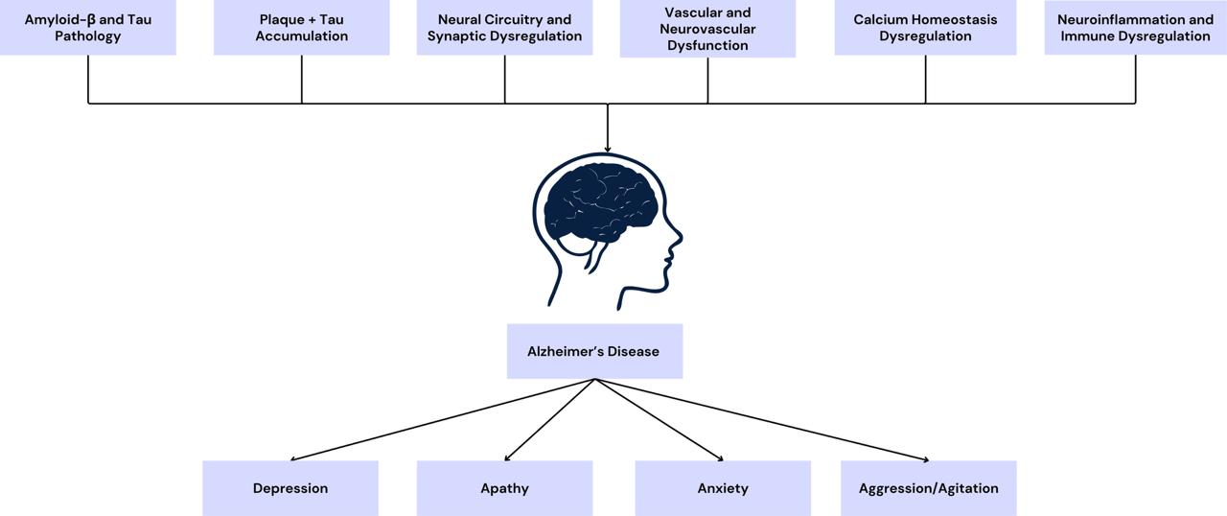
Figure 6: Biological Markers of AD and its association with the progression of various NPS
In conclusion, previous research conducted on AD pathology lists numerous biomarkers and factors linked to its onset, and cause neurodegeneration, such as amyloid and tau accumulation, synaptic dysfunction, as well as other factors like atrophy in the hippocampal region, ventricular enlargement, and thinning of cortical regions of the brain, which are showcased through structural MRI scans [87] Similarly, disruption in white matter volume and disruption in neural networks, key to important cognitive and mental processes, which are hallmarks for AD and contribute to the onset of NPS, are also detectable via MRI [88], [89]. Hence, we can infer from these studies that having accurate stage-wise differentiation of AD stages, including the detection of subtle structural differences and alterations in key brain regions and associated factors, is plausible and important. Detection of dysfunction in attentional and cognitive networks, due to degeneration, which causes major changes in behaviour and regulation, directly affect patient’s quality of life. Thus, accurate MRI-based staging is not only important for showcasing worsening of symptoms, but also to reflect evolving structures under NPS expression, which can allow for a more biologically sound framework.
  - Neuropsychiatric symptoms (NPS) within AD
Prevalence rate of NPS, such as depression, anxiety, apathy, agitation, etc., within AD patients is critically high, up to 97% of all AD patients [16] wherein nearly 99% of all patients with dementia and AD will manifest at least one of the NPS during the course of illness [3]. Some of the common symptoms are explained below.
    - Depression within AD
One of the most devastating and important NPS to focus on is depression, for which there is a roughly 40% prevalence rate of depression-like symptoms within AD patients [90] and higher rates of caregiver depression, which in turn worse quality of care of patients, which can worsen their symptoms [91] and additionally, as highlighted in the study conducted by Kazmierski [92] it has been linked to significant impairment in life quality; lower cognitive capacity and functioning; poorer ADL skills; a higher number of aggressive outbursts, all of which can lead to further problems during the course of AD. To further highlight the devastating impact depression can have within AD, a study conducted by Huang et al. [93] showcases how untreated depression is linked to increase in dementia risks, by up to 30%; patients who experience their first depressive episodes after the age of 60 have been noted to have higher rates of decline in cognitive capacity and functioning and associated skills, like speaking, problem-solving, etc.; continuing, or worsening, of depressive symptoms is a predisposing factor to AD. A study conducted by Harerimana et al. [94] showcases a genetic overlap between AD and depression, particularly causal genetic effect of depression on AD, emphasising on the genetic contribution of depression on AD; depression-linked genetic variants contribute to faster cognitive decline via alteration in genetic structure of brain and protein expression; higher polygenic risk scores of depression also significantly predicts decline in memory and cognitive functioning, thus further reinforcing the effects that depression has on patients with AD.
A study conducted by Xu et al. [95] highlights the biological factors contributing to the development of depression within AD patients, wherein greater amyloid-β plaques and tau concentration have been associated with more depressive symptoms, particularly via damage to hippocampal neurons due to high levels of cortisol, resultant of HPA hyperactivation; dysregulation in GABAergic systems, causing inability to inhibit neuronal impulses, which also leads to problems in network coordination within the brain, elevation in IL-6, TNF-α, IL-1β (pro-inflammatory cytokines), which directly increase amyloid-β plaques concentration and similarly, another study done by Wu et al. [96] focuses on how depression is linked to neurodegeneration in key regions of the brain, namely PFC, hippocampus, and cingulate cortex (regions responsible for emotions, memory, and mood regulation) where damage here are similar to those found within patients of AD, highlighting how depression can be viewed as an early pathological marker for the onset of AD, appearing even before any signs of cognitive decline manifest, and is not just a secondary symptom of it. Focusing on HPA-activation and chronic stress, consistently high levels of cortisol continue damaging hippocampal neurons, leading to impairments in memory, along with it increasing amyloid-β and tau accumulation, while also at the same time leading to higher levels of oxidative stress which, as previously highlighted, causing further damages to neuron, mitochondrial dysfunction, reduced synaptic plasticity, and overall shrinkage in hippocampus, wherein all these conditions contributed towards a higher vulnerability to depression, explaining its manifestation within AD patients [97]
In conclusion, the previous studies as listed above cite numerous pathological markers and biological/neurological factors and symptoms associated with the onset of depression, particularly in AD patients, including hippocampal and amygdala dysfunction, ACC impairments, and structural alterations in key brain regions, which are assessed through structural MRI scans [98]. Further studies also confirm the ability of MRI-based scans to accurately detect structural changes within brain regions of AD patients with depression, especially atrophy in regions associated with PFC networks and the limbic cortex [99], [100]. As highlighted in the previous sections, the onset of depression is closely linked to different disease-stages of AD, which reflects the evolving structural changes and vulnerabilities. MRI-based staging, thus, offers a more biologically and clinically relevant framework for better understanding variability in depressive burden in AD patients.
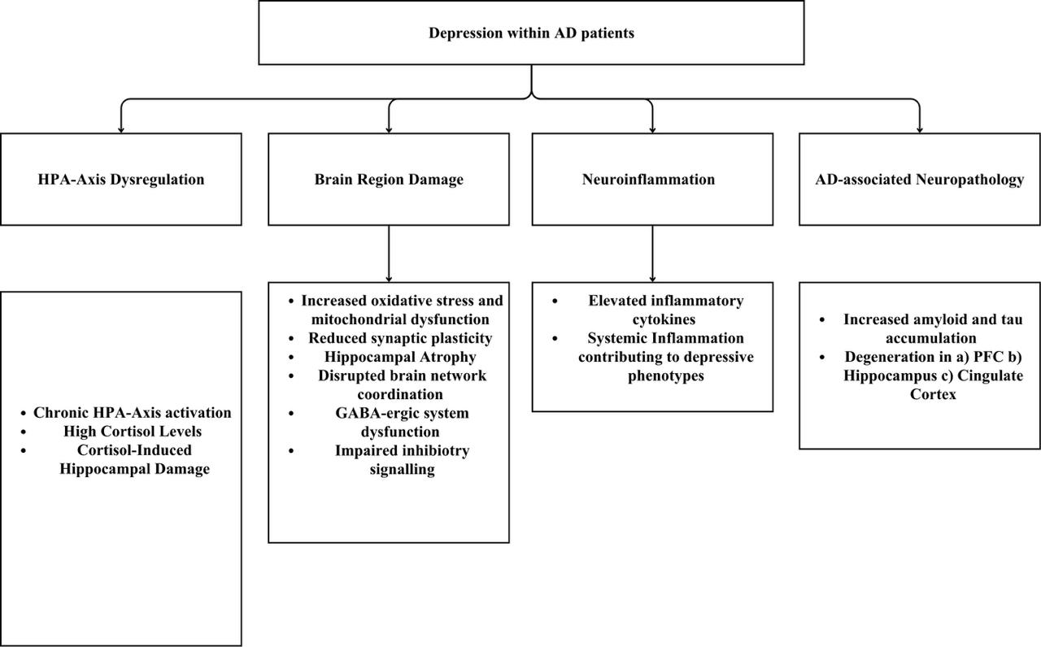
Figure 7 : Depression in AD arises from interaction of pathways involving hyperactivation of HPA-axis, GABA Dysfunction, amyloid/tau-related neurodegeneration, and inflammation
    - Anxiety within AD
Anxiety-based disorders have been noted as one of the most common NPS within the AD population, where the prevalence rates reach about 39% of the AD population [101]where anxiety has been associated with higher rates of impairment in cognitive functioning, along with dementia and AD, wherein individuals with higher rates of anxiety were found to have a 24% higher risk of developing dementia, and almost 4% of all dementia cases could be linked to anxiety, whereas updated evidence and studies, done by Santabárbara et al. [102] showcase that the actual number is much higher, wherein 45% of individuals with anxiety have higher chances of developing AD relative to those who are devoid of these symptoms. Overall, anxiety-based disorders within AD patients have been associated with poor quality of life, increased risk of caregiver stress, negative effects on memory and attention, and other associated factors [16]
Studies focusing on the pathological markers of anxiety within AD patients have emphasised reduced usage of brain energy, i.e., FDG-PET hypometabolism, as well as the presence of the APOE-ε4 allele, which makes the progression from MCI to AD at a relatively faster rate, along with changes in amyloid levels Similarly, other studies conducted by Botto et al. [11] highlights certain biological factors causing anxiety within AD patients, particularly more severe during early onset,: a) atrophy in various brain regions, including right precuneus and IPL b) too much blood flow (hyperperfusion) in ACC c) impairments in metabolism in temporal and parahippocampal gyrus, along with EC and insula d) altered activity of glycine receptors (GlyRS) and NMDA NR2A receptors e) higher concentration of amyloid-β and tau, with it often appears before cognitive decline, similar to depression, and thus, becomes a very important clinical marker for onset of AD. Focusing on associated causes between anxiety and AD, numerous factors such as: a) reduced BDNF and atrophy in key regions of brain associated with memory and emotion regulation b) inflammation of CNS, due to high levels of inflammatory cytokines, similar to that of depression c) high levels of cortisol, due to dysregulation of HPA, thus causing hippocampal neuronal damage d) impairments in serotonin system, along with higher amyloid burden, in both anxiety and AD where people with both higher levels of anxiety and more Aβ burden show faster rates of cognitive decline and functioning e) usage of common anxiety alleviating medications, particularly anxiolytics and benzodiazepines, have been linked to higher onset rates of dementia and AD [103], [104] Moreover, a study conducted by Azocar et al. [105] showcases how people with AD who are more aware of their deficits in cognitive functioning and memory capacity are more likely to suffer higher instances of anxiety-like symptoms, relative to those whose awareness about their symptoms is impaired, wherein psychological interventions that were targeted at reducing anxiety symptoms within patients were also found to reduce future rates of or risks of developing dementia and AD [106]
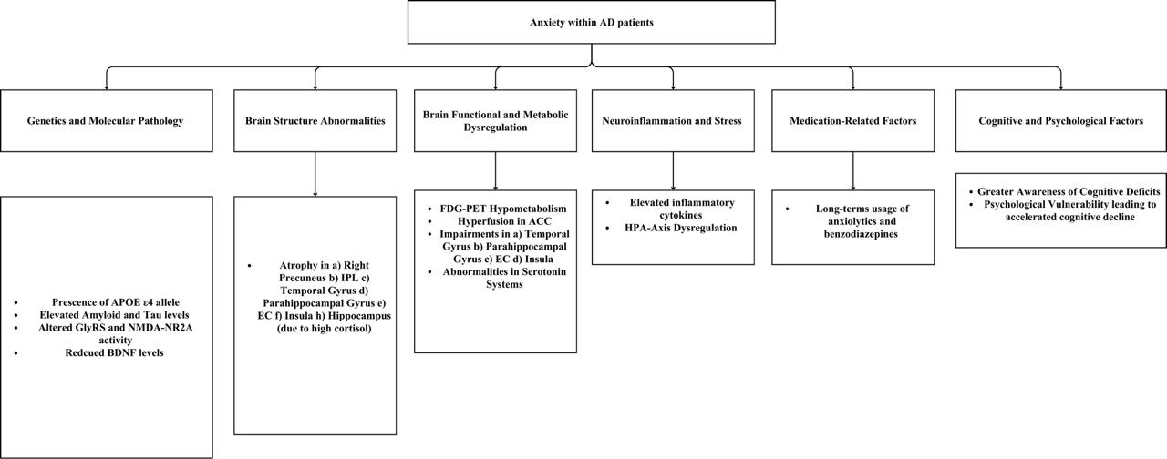Figure 8 : Anxiety in AD arises from pathways involving APOE allele related vulnerability, amyloid/tau pathology, neuroinflammation, and HPA-axis dysregulation, leading to metabolic and structural brain changes
Additionally, studies have also showcased how anxiety leads to alterations in key networks in the brain, namely the amygdala circuits and their interconnections with the hippocampus, wherein these connections show degeneration amongst populations with dementia and AD [107], [108]. Structural MRI scans of patients with AD, who also displayed symptoms of anxiety, showcased disruption in key regions of the brain, especially limbic and salience networks, as well reduction in grey matter volume in numerous associated brain regions [109]. Such key alterations of the brain that reflect anxiety-associated changes within AD patients are meaningfully observed through structural MRI scans, and as previous sections note how presentation of anxiety symptoms differ across disease-progression of AD, the present framework, which allows for stage-wise differentiation, can benefit from integrating neural susceptibility associated with anxiety to enhance treatment and diagnosis.
    - Apathy within AD
Classified as the most common NPS within AD patients, showcasing prevalence rates of 53-92%, which has been noted to increase caregiver burden, due to high demands and support needed by patients, an inability to make their own decisions regarding achieving desired goals, or initiate necessary or basic work, thus showcasing problems with ADLs, as well as higher rates of mortality rates amongst the AD population, with rates 3 times higher relative to those who are devoid of apathy or show minimal symptoms, and has also been linked to lower levels of empathy, motivation, and dysfunction/impairments in executive functioning [16], [110], [111], [112], [113] .
Risk factors for development of apathy within AD patients include a mix of several biological and neurological factors, including impaired Aβ and tau concentration levels, as commonly found within patients of AD; altered inflammatory cytokine, especially TNF-α, IL-1, and IL-10 levels; increased cortisol levels in CSF; associated personality changes and pre-morbid personality traits, such as lower motivation, poorer life quality, and baseline level of apathy being higher than normal also increase vulnerability to greater apathy after AD onset; disruptions in ACC and DLPFC, which are motivation, decision-making, and evaluation centres, causing difficulties in flexibility and goal-setting; impairments in the salience network of the brain, leading to inhibitions in memory and diminished emotional responsiveness; patients with AD report lower dopamine and noradrenergic levels, contributing to higher apathy, as well as greater onset of MCI; psychologically, worsening of AD has been linked to poorer executive functioning, causing difficulties in planning and execution thus, leading to more apathy; diminished activity of DMN system, whose faulty activity is a major causal factor of AD, which further leads to impairments in self-generated thoughts, recalling memories, and lower brain energy output, all further contributing to higher levels of apathy [114], [115], [116], [117], [118], [119], [120]. Other studies highlighted more factors associated with onset/worsening of apathy within AD patients, namely: a) carrying a single nucleotide polymorphism of PRND 3’UTR gene, on the T allele, which doubles the risk of onset b) neurodegeneration within IT cortex c) longer course of AD, along with poor episodic memory, predicts significant worsening of apathy-like symptoms d) dysregulations in white matter networks e) lower hippocampal volume [121], [122]

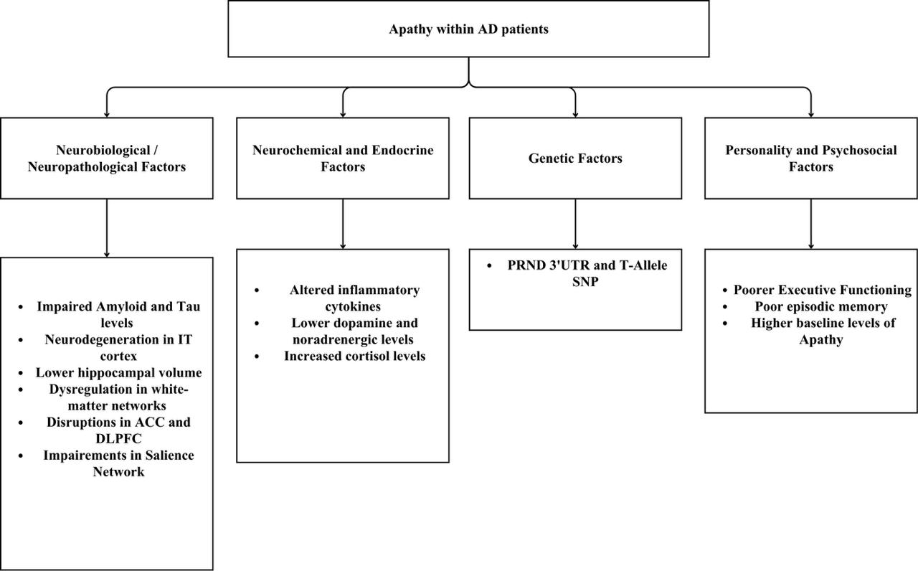
Figure 9 : Apathy in AD arises from pathways including neurodegeneration, neurotransmitter and endocrine dysregulation, genetic vulnerability, and personality-related predispositions
In conclusion, previous studies highlight numerous associated biomarkers and neurological changes associated with apathy in AD patients, which can be meaningfully assessed through structural MRI scans. For instance, apathy is associated with cortical thinning, especially in right OFC and ACC, along with disruptions in frontolimbic and frontoparietal networks, as noted via MRI scans of patients with MCI and AD [123], [124]. Additionally, another study by Yu et al. [125] also displayed cortical thinning within apathy-AD patients, corroborating the previous study, while also displaying disruptions in the corpus callosum and irregular inter-hemispheric connections, leading to functional decline. Such findings highlight the view that NPS, like apathy, develops along with AD-related pathological changes noted within stage-wise changes, which can be assessed through an MRI-based disease staging framework.
    - Aggression and Agitation within AD
With a global prevalence rate reaching about 48.9% of patients with AD [126] aggression/agitation tendencies, behaviours, and outburst within patients with dementia and AD was found to be the major cause for hospitalisation, due to potential vulnerability to self-harming tendencies or a need to harm others, leading to increased caregiver burden, where approximately 28% of patients with AD report major aggressive tendencies, wherein 8% of patients with AD who engaged in criminal activities stated the major cause to be physical aggression, whereas a higher incidence of verbal aggression, nearly 28-67% of patients with AD, has been noted, and has been associated with a) difficulties in social functioning b) self-damaging or potentially harmful behaviour, like self-harm, wandering, abuse, etc. c) behavioural issues d) poor caregiver relationship e) onset of other NPS, especially depression due to social isolation [16], [127] where the prevalence of agitation tendencies increases with the severity of dementia, and is mostly found within frontotemporal dementia [128].
Several neurobiological markers of the onset of agitation with patients of dementia and AD have been recognised, namely: a) disruption in white matter integrity in various key networks of the brain, especially SFOF, fornix, uncinate fasciculus, etc., b) amyloid-β burden, a common biological marker for AD c) parahippocampal damage /atrophy, along with PCA, d) higher amounts of inflammation e) higher levels of oxidative stress [129], [130], [131]. Studies focusing on disruptions in specific brain regions and neurotransmitter systems have been linked to the onset of agitation within AD patients, such as the study conducted by Saggu et al. [132] state how regions that are essential for emotion regulation, fear perception, and important for emotionally significant stimuli, such as ACC and PCC, FC, amygdala, and hippocampus, along with disrupted levels of serotonin and cholinergic systems, reduced grey matter in various regions of the brain especially bilateral ACC and left insula, and dopamine receptor disruptions, especially of D2/D3 receptor and 5HT2A receptor impairments. Additionally, a study conducted by Liu et al. [133] also theorises how degeneration in the locus coeruleus noradrenergic system, a biological change common within AD patients, can be associated with the onset of agitation. Diverting our attention away from biological/medical causes, and on social and psychological influences, a study done by Outen et al. [134] showcases how low SES, an overstimulating environment, and/or family conflicts, along with increased caregiver burden, are associated with psychological conditions like delirium, increased stress due to pain, side effects from medications, increased pain and weakness of the body (frailty, especially in older adults with AD), have been linked to the onset of agitation/aggression.
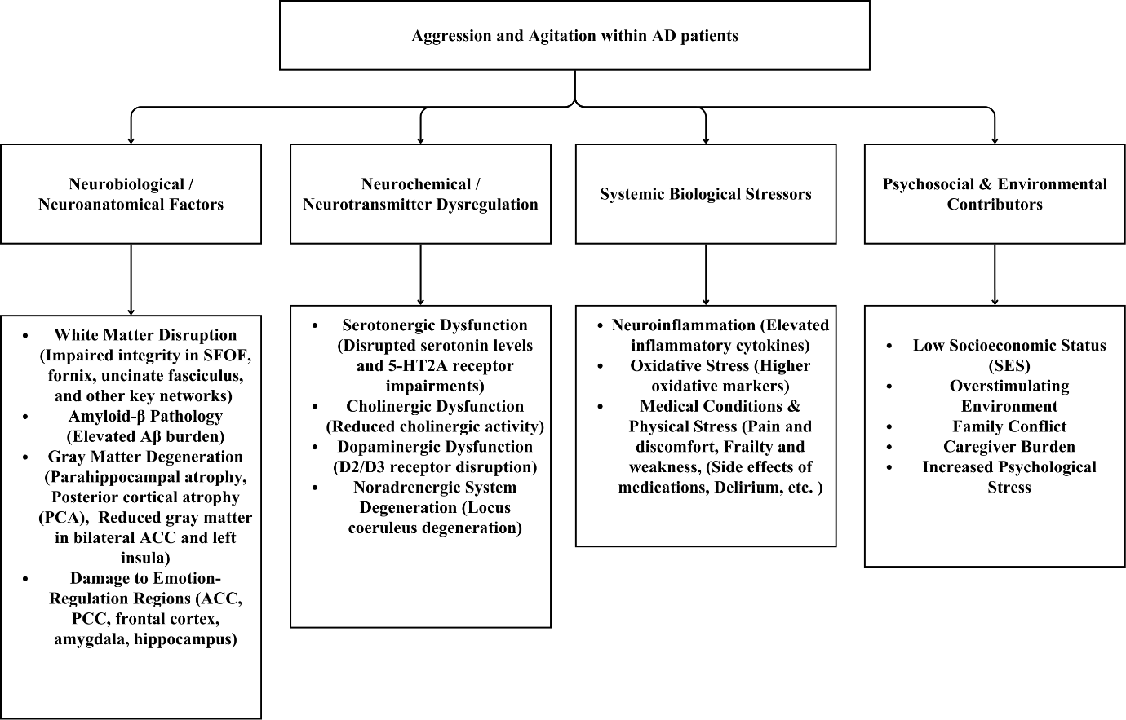
Figure 10 : Aggression and Agitation in AD arise from pathways involving neuroanatomical differences, neurotransmitter dysregulation, biological stressors, and psycho-socio-environmental factors

In conclusion, agitation and aggressive behaviour within AD patients is meaningfully associated with marked alterations in the neurotransmitter system, especially serotonin and dopaminergic systems [135] including irregularity in frontal lobe development and atrophy in the right hemispheric regions, noted in early stages [136]. Structural MRI scans of AD patients reveal key important biomarkers and anatomical changes within the brain, associated with the onset of aggression, namely thinning in cortical areas (medial, temporal, and parietal cortex) and irregularities in the temporal gyrus [137] as well as being capable of tracking stage-wise severity and prevalence of aggression across stages of AD (from NC – MCI – AD), revealing irregular white matter connectivity, and disruptions in key limbic circuitry and long-associated fibre systems . Such MRI-based findings indicate the need for stage-sensitive classification models that can reflect the neurological and anatomical changes pertaining to agitation/aggression, and how utilising them within the diagnostic framework can help towards AD treatment and detection.
  - Neuropsychiatric Symptoms (NPS) as Preclinical Indicators
Emerging and growing literature within AD has emphasised the role of NPS as potential early markers for subsequent cognitive impairment, dementia, and onset of AD, even before any cognitive decline or subsequent symptoms are noticed. For example, in a study conducted by Kim et al. [138] highlighted how NPS were highly associated with decline in cognitive capacity and functioning, along with a threefold higher risk of developing MCI and dementia, showcasing how NPS preceded both of them, with a possible explanation of this pattern being the neurodegenerative processes that are the underlying causes of these NPS, as highlighted in the above sections. Similarly, another study conducted by Eikelbloom et al. [139] also emphasises on the emergence of various NPS, especially depression and apathy, within patients who had a high amyloid-β burden, a common marker for AD, even before any measurable cognitive deficit emerged, where higher severity of these NPS also correlated with more negative impacts on cognition, thus serving as important guides for early identification and monitoring for people at risk of AD. Additionally, any significant pathological changes within these NPS also increase the risk/onset of more cognitive impairment even amongst individuals free of AD biomarkers, highlighting the importance of management of these symptoms as a potential intervention for preventing any maladaptive changes occurring to cognitive capacity/functioning [140]. To further corroborate with the previous points, another study conducted by McGirr et al. [141] also showcased how NPS were found to majorly increase dementia progression, as highlighted in the study where people with NPS, like depression, apathy etc. were two times more likely to progress to dementia onset, along with significantly increasing the likelihood of cognitive impairment, and were less likely to revert to normal cognitive functioning, thus highlighting the roles of NPS are important pre-clinical markers for both dementia and AD.
Further literature that showcases how NPS emerge before cognitive decline, such as the study done by Ng et al. [142] which highlights how majorly depression, anxiety, apathy, and agitation were amongst the most important NPS within the context of pre-clinical markers, with the findings showcasing how people who a) are closer to onset of AD b) have higher severity of NPS showcased a higher rate of degeneration in cerebral glucose metabolism, which is a crucial marker for oncoming neurodegeneration i.e. an important hallmark for AD, and interestingly enough, this effect was absent in non-AD individuals, further solidifying the importance and specificity of the role of NPS as markers to AD-related process and onset. Another important study within this context was done by Pink et al. [143] wherein findings showcase how 21% of individuals showcased at least one NPS, even before any cognitive impairment occurred, along with the patterns of cognitive decline wherein individuals who had both elevated amyloid levels and NPS had faster rates of decline, rather than those who had only of the two, along with the NPS acting and behavioural manifestation of the amyloid burden on neural system, wherein these predicted memory and attention decline, which are hallmarks of AD thus, reinforcing the importance of incorporating NPS to improve prediction and early monitoring for dementia and AD.
Moreover, when late-life NPS evolve into MBI, individuals who were MBI positive 5 years before death are significantly more likely to display AD pathology, relative to those who are non-MBI positive, along with making MBI + individuals two times more likely to develop AD, relative to those without NPS, thus highlighting the importance of NPS as important pre-clinical markers, especially when they manifest in the form of mild behavioural impairment (MBI) [31]. To further add to the importance of MBI within AD research, a study conducted by Naude et al. [144] showcases how individuals with significant amyloid burden, along with MBI-positive diagnosis, were linked to significant tau burden as well, which is a hallmark for AD, whereas only having amyloid burden and not being MBI+ + did not predict tau burden. Additionally, another study conducted on MBI by Leow et al. [145] showcases how NPS as captured as behavioural impairment are linked to early pathological/biological markers of AD, wherein individuals who were MBI + were also found to have cortical thinning in temporal, parietal, and insular cortices, which are regions known to be affected early in AD, along with greater amyloid and tau burden, thus emphasising how these NPS reflect neurodegeneration associated with AD onset, even before any cognitive decline can be found.
Additionally, individuals with apathy symptoms were seen to have more faster memory decline, along with lapses in executive functioning, while also increasing the risk of progression from MCI to AD, highlighting how these NPS manifestation are not random secondary outcomes of AD, but are extremely important early clinical/pathological markers for onset, and can be utilised for effective early monitoring within individuals at risk of AD [146]. Focusing on apathy, a study done by Zhu et al. [147] showcases how apathy appeared before any major deficits in cognitive functioning and significantly predicted functional decline within AD and dementia patients, thus representing sensitivity to further deterioration and as an important pre-clinical marker for the onset. Moreover, a study conducted by Goodwin et al. [148] showcases how anxiety, agitation/irritability, along with depression correlated with a faster rate of decline among executive functioning, leading to a difficulty in planning and executing actions which is a key sign of AD, wherein these were reported at a 3 times faster rate of decline relative to those who did not have these symptoms and even before any signs of cognitive impairment, hence highlighting the importance of early detection of NPS for AD risk assessment. Additionally, a study conducted by Shah et al. [149] showcased how NPS go beyond being outcomes/symptoms of AD, but are essential tools of diagnosis as well wherein feeding NPS-related markers to ML models improved prediction of cognitive decline, along with determining risk of progression from MCI to dementia and/or AD, along with levels of memory and attention as well, thus reinforcing the importance of NPS as an essential pre-clinical diagnosis tool for early detection of AD.
In conclusion, across recent studies and scientific literature point to NPS, especially depression, anxiety, apathy, and aggression/agitation, as not being only secondary outcomes/symptoms of AD, but as significant potential markers for it, often appearing not only before cognitive decline but are linked to associated pathological/biological processes that are linked to AD, neurodegeneration, and amyloid and tau burden. Furthermore, as stated in the previous sections, NPS evolve in prevalence, intensity, and severity across the stages of AD, which are trackable through structural MRI scans. As a result, incorporating them as meaningful symptomatic clinical markers of AD, in association with stage-wise differentiation of AD prognosis, can further enhance diagnosis and assessment.
  - Limitations of the study
The study, despite its strengths, has the following limitations. Firstly, the data was taken from a single, public source, which can lead to overreliance and possible bias in decision-making. Secondly, the model relied exclusively on MRI scans, and not additional biomarkers or cognitive/neuropsychiatric assessments, and future integration of these systems may enhance stage-wise early detection. Thirdly, true real-world applicability can only be determined after its deployment in actual clinical settings, which will reveal performance cross a diverse clientele. Finally, the study did not incorporate actual NPS profiling within the stage-wise detection and differentiation, and only points towards its possible future integration, which may allow for more informed clinical decision-making.
- CONCLUSION
The present study aimed to develop a valid framework for stage-wise classification of Alzheimer's Disease using structural MRI scans, and thus, formulated a hybrid deep-classical machine learning (ML) framework. By utilising trained architectures, namely EfficientNetV2-S for deep, hierarchical feature extraction, XGBoost for informed, optimised stage-wise classification, and TruncatedSVD for reduction of dimensionality, it allowed for improved generalisation and stability of results. Evaluation was done across 4 diagnostic categories, namely Non-Demented (ND), Very Mildly Demented (VMD), Mildly Demented (MD), and Moderate Demented (MOD), displaying a high accuracy (93%) across all four categories, and ROC-AUC values ranging from 0.91 to 0.96, on non-augmented data. Confusion matrix displayed minimal misclassification in MOD and ND stages, with only few misclassifications occurring in ND and VMD stages, mainly due to certain structural overlap which is to be expected. Class-wise evaluation shows very high discrimination (0.99-1.00) across all four categories, further enhancing the model’s reliability. Other analysis done, include t-SNE and KDE probability calibration further showcased the model’s efficiency in accurate differentiation between AD stages and stability in decision boundaries, especially in MOD stage, while also displaying efficient differentiation in earlier stages where structural stages are more subtle. This allows for a more clinically meaningful framework, which is applicable in real-world settings and generalisable. Utilising a large, heterogenous dataset of 40,000+ original MRI scans further enhance the validity of the findings and contribute toward potential integration of additional meaningful biomarkers and neuropsychiatric symptoms, that will allow for improvement in diagnosis. In conclusion, the model showcases high methodological rigour and scalable, interpretable results that have high clinical relevance, and can be utilised as efficient frameworks within AD treatment and diagnosis.
The present model displays high reliability and accuracy and can be enhanced by utilisation of other frameworks and avenues. Firstly, integrating other biomarkers, such as EEG scans, PET imaging, CSF markers, APOE status, etc. may allow for even earlier-stage sensitivity and classification, allow for pre-clinical detection that goes beyond degeneration of structural features alone. Secondly, combining the stage-wise classification via imaging features with neuropsychological assessment, such as MMSE scores, and NPS profiling can further allow for a biological-psychological relevant model, allowing for biologically sound staging while also displaying correlations with the behavioural manifestations of associated symptoms, like depression, apathy, anxiety, etc. during disease progression. Thirdly, a longitudinal analysis where repeated imaging is conducted across different time-points will reveal more information regarding transition possibilities from MCI to AD. Finally, deployment of the above model in real-world settings will allow for more practice, training, and real-time integration regarding hospital workflow and clinician requirement, giving more insight into creating a scalable and medically-sound AI system for AD management.
DECLARATIONS
Ethical approval and consent to participate: Not applicable.
Consent for publication: Not applicable
Availability of data and material: Not applicable.
Clinical trial number: Not applicable.
Competing interests: The authors have no conflicts of interest to declare.
Funding: Not applicable.
REFERENCES
[1] A. A. Rostagno, “Pathogenesis of Alzheimer’s Disease,” Int. J. Mol. Sci., vol. 24, no. 1, p. 107, Dec. 2022, doi: 10.3390/ijms24010107.
[2] B.-K. Beata, J. Wojciech, K. Johannes, L. Piotr, and M. Barbara, “Alzheimer’s Disease—Biochemical and Psychological Background for Diagnosis and Treatment,” Int. J. Mol. Sci., vol. 24, no. 2, p. 1059, Jan. 2023, doi: 10.3390/ijms24021059.
[3] K. Pinyopornpanish et al., “Author Correction: Impact of behavioral and psychological symptoms of Alzheimer’s disease on caregiver outcomes,” Sci. Rep., vol. 15, no. 1, p. 19985, Jun. 2025, doi: 10.1038/s41598-025-02780-8.
[4] B. Kim, G. O. Noh, and K. Kim, “Behavioural and psychological symptoms of dementia in patients with Alzheimer’s disease and family caregiver burden: a path analysis,” BMC Geriatr., vol. 21, no. 1, p. 160, Dec. 2021, doi: 10.1186/s12877-021-02109-w.
[5] J. Jia et al., “Comprehensive Management of Daily Living Activities, behavioral and Psychological Symptoms, and Cognitive Function in Patients with Alzheimer’s Disease: A Chinese Consensus on the Comprehensive Management of Alzheimer’s Disease,” Neurosci. Bull., vol. 37, no. 7, pp. 1025–1038, Jul. 2021, doi: 10.1007/s12264-021-00701-z.
[6] F. Bature, B. Guinn, D. Pang, and Y. Pappas, “Signs and symptoms preceding the diagnosis of Alzheimer’s disease: a systematic scoping review of literature from 1937 to 2016,” BMJ Open, vol. 7, no. 8, p. e015746, Aug. 2017, doi: 10.1136/bmjopen-2016-015746.
[7] S. Rajanna, P. P. Gundale, and A. Dev Mahadevaiah, “Advancements in the treatment of Alzheimer’s disease: a comprehensive review,” Dement. Neuropsychol., vol. 19, 2025, doi: 10.1590/1980-5764-dn-2024-0204.
[8] D. S. Geldmacher, “Treatment of Alzheimer Disease,” Continuum (N. Y)., vol. 30, no. 6, pp. 1823–1844, Dec. 2024, doi: 10.1212/CON.0000000000001503.
[9] G. Argiris et al., “Data-driven CSF biomarker profiling: imaging and clinical outcomes in a cohort at risk of Alzheimer’s disease,” Alzheimers Res. Ther., vol. 16, no. 1, p. 274, Dec. 2024, doi: 10.1186/s13195-024-01629-y.
[10] M. R. Jenkins et al., “Behavioral and psychological symptoms of dementia and Alzheimer’s disease progression in Down syndrome,” J. Neurodev. Disord., vol. 17, no. 1, p. 19, Apr. 2025, doi: 10.1186/s11689-025-09604-w.
[11] R. Botto, N. Callai, A. Cermelli, L. Causarano, and I. Rainero, “Anxiety and depression in Alzheimer’s disease: a systematic review of pathogenetic mechanisms and relation to cognitive decline,” Neurological Sciences, vol. 43, no. 7, pp. 4107–4124, Jul. 2022, doi: 10.1007/s10072-022-06068-x.
[12] R. A. Sperling et al., “Amyloid and Tau Prediction of Cognitive and Functional Decline in Unimpaired Older Individuals: Longitudinal Data from the A4 and LEARN Studies,” J. Prev. Alzheimers Dis., vol. 11, no. 4, pp. 802–813, Aug. 2024, doi: 10.14283/jpad.2024.122.
[13] U. C. Dash et al., “Oxidative stress and inflammation in the pathogenesis of neurological disorders: Mechanisms and implications,” Acta Pharm. Sin. B, vol. 15, no. 1, pp. 15–34, Jan. 2025, doi: 10.1016/j.apsb.2024.10.004.
[14] T. Song et al., “Mitochondrial dysfunction, oxidative stress, neuroinflammation, and metabolic alterations in the progression of Alzheimer’s disease: A meta-analysis of in vivo magnetic resonance spectroscopy studies,” Ageing Res. Rev., vol. 72, p. 101503, Dec. 2021, doi: 10.1016/j.arr.2021.101503.
[15] E. H. Seo et al., “Visuospatial memory impairment as a potential neurocognitive marker to predict tau pathology in Alzheimer’s continuum,” Alzheimers Res. Ther., vol. 13, no. 1, p. 167, Dec. 2021, doi: 10.1186/s13195-021-00909-1.
[16] A. Pless, D. Ware, S. Saggu, H. Rehman, J. Morgan, and Q. Wang, “Understanding neuropsychiatric symptoms in Alzheimer’s disease: challenges and advances in diagnosis and treatment,” Front. Neurosci., vol. 17, Sep. 2023, doi: 10.3389/fnins.2023.1263771.
[17] H. Wang, S. Li, J. Zhang, W. Peng, T. Li, and J. Zhang, “Efficacy of selective serotonin reuptake inhibitors-related antidepressants in Alzheimer’s disease: a meta-analysis,” Eur. J. Med. Res., vol. 29, no. 1, p. 438, Aug. 2024, doi: 10.1186/s40001-024-02006-z.
[18] J. M. García-Alberca et al., “Effectiveness of Vortioxetine Treatment on Depression and Cognitive Functions in Patients with Alzheimer’s Disease: A 12-Month, Retrospective, Observational Study,” J. Pers. Med., vol. 14, no. 9, p. 918, Aug. 2024, doi: 10.3390/jpm14090918.
[19] C. Andrade, “Methylphenidate and Other Pharmacologic Treatments for Apathy in Alzheimer’s Disease,” J. Clin. Psychiatry, vol. 83, no. 1, Feb. 2022, doi: 10.4088/JCP.22f14398.
[20] P. R. Padala, K. P. Padala, A. S. Majagi, K. K. Garner, R. A. Dennis, and D. H. Sullivan, “Selective serotonin reuptake inhibitors-associated apathy syndrome,” Medicine, vol. 99, no. 33, p. e21497, Aug. 2020, doi: 10.1097/MD.0000000000021497.
[21] F. Maier et al., “Bupropion for the Treatment of Apathy in Alzheimer Disease,” JAMA Netw. Open, vol. 3, no. 5, p. e206027, May 2020, doi: 10.1001/jamanetworkopen.2020.6027.
[22] H. Dolphin, A. H. Dyer, C. McHale, S. O’Dowd, and S. P. Kennelly, “An Update on Apathy in Alzheimer’s Disease,” Geriatrics, vol. 8, no. 4, p. 75, Jul. 2023, doi: 10.3390/geriatrics8040075.
[23] T. Gress, M. Miller, C. Meadows, and S. M. Neitch, “Benzodiazepine Overuse in Elders: Defining the Problem and Potential Solutions,” Cureus, Oct. 2020, doi: 10.7759/cureus.11042.
[24] C. Carrarini et al., “Agitation and Dementia: Prevention and Treatment Strategies in Acute and Chronic Conditions,” Front. Neurol., vol. 12, Apr. 2021, doi: 10.3389/fneur.2021.644317.
[25] J. Li, A. Haj Ebrahimi, and A. B. Ali, “Advances in Therapeutics to Alleviate Cognitive Decline and Neuropsychiatric Symptoms of Alzheimer’s Disease,” Int. J. Mol. Sci., vol. 25, no. 10, p. 5169, May 2024, doi: 10.3390/ijms25105169.
[26] N. C. Reyna, B. J. Clark, D. A. Hamilton, and N. S. Pentkowski, “Anxiety and Alzheimer’s disease pathogenesis: focus on 5-HT and CRF systems in 3xTg-AD and TgF344-AD animal models,” Front. Aging Neurosci., vol. 15, Nov. 2023, doi: 10.3389/fnagi.2023.1251075.
[27] I. vom Hofe, B. H. Stricker, M. W. Vernooij, M. K. Ikram, M. A. Ikram, and F. J. Wolters, “Benzodiazepine use in relation to long-term dementia risk and imaging markers of neurodegeneration: a population-based study,” BMC Med., vol. 22, no. 1, p. 266, Jul. 2024, doi: 10.1186/s12916-024-03437-5.
[28] C. G. Lyketsos and M. E. Peters, “Neuropsychiatric symptoms in Alzheimer’s disease: Past, present, and future,” Alzheimer’s & Dementia, vol. 22, no. 1, Jan. 2026, doi: 10.1002/alz.71077.
[29] D. de L. Raphael, “Neuropsychiatric symptoms in mild cognitive impairment and early Alzheimer’s disease: Clinical pattern and diagnostic implications,” AIMS Neurosci., vol. 12, no. 4, pp. 676–705, 2025, doi: 10.3934/Neuroscience.2025032.
[30] M. Ruthirakuhan, D. X. Guan, M. Mortby, J. Gatchel, and G. M. Babulal, “Updates and future perspectives on neuropsychiatric symptoms in Alzheimer’s disease,” Alzheimer’s & Dementia, vol. 21, no. 3, Mar. 2025, doi: 10.1002/alz.70079.
[31] S. F. Sharif et al., “Neuropsychiatric symptoms and progression to pathologically confirmed Alzheimer’s disease,” Brain, vol. 148, no. 10, pp. 3694–3704, Oct. 2025, doi: 10.1093/brain/awaf156.
[32] R. Wang, “Global burden of Alzheimer’s disease and other dementias during 1990-2021: a Global Burden of Disease and Risk Factors Study 2021-based study,” Neuroepidemiology, pp. 1–24, Jan. 2025, doi: 10.1159/000543578.
[33] A. Nandi et al., “Global and regional projections of the economic burden of Alzheimer’s disease and related dementias from 2019 to 2050: A value of statistical life approach,” EClinicalMedicine, vol. 51, p. 101580, Sep. 2022, doi: 10.1016/j.eclinm.2022.101580.
[34] J. Cummings et al., “Drug development in Alzheimer’s disease: the path to 2025,” Alzheimers Res. Ther., vol. 8, no. 1, p. 39, Dec. 2016, doi: 10.1186/s13195-016-0207-9.
[35] S. Fernandes, A. von Gunten, and H. Verloo, “Using AI-Based Technologies to Help Nurses Detect Behavioral Disorders: Narrative Literature Review,” JMIR Nurs., vol. 7, p. e54496, May 2024, doi: 10.2196/54496.
[36] T. Mahmud, K. Barua, S. U. Habiba, N. Sharmen, M. S. Hossain, and K. Andersson, “An Explainable AI Paradigm for Alzheimer’s Diagnosis Using Deep Transfer Learning,” Diagnostics, vol. 14, no. 3, p. 345, Feb. 2024, doi: 10.3390/diagnostics14030345.
[37] P. T and S. V, “Performance evaluation of Alzheimer’s disease detection in brain MRI images using the Alzheimer-net classifier,” Engineering Research Express, vol. 7, no. 3, p. 035209, Sep. 2025, doi: 10.1088/2631-8695/ade8d5.
[38] M. Asaduzzaman, Md. K. Alom, and Md. E. Karim, “ALZENET: Deep learning-based early prediction of Alzheimer’s disease through magnetic resonance imaging analysis,” Telematics and Informatics Reports, vol. 17, p. 100189, Mar. 2025, doi: 10.1016/j.teler.2025.100189.
[39] C. M. Chabib, L. J. Hadjileontiadis, and A. Al Shehhi, “DeepCurvMRI: Deep Convolutional Curvelet Transform-Based MRI Approach for Early Detection of Alzheimer’s Disease,” IEEE Access, vol. 11, pp. 44650–44659, 2023, doi: 10.1109/ACCESS.2023.3272482.
[40] N. Hassan, A. S. M. Miah, K. Suzuki, Y. Okuyama, and J. Shin, “Stacked CNN-based multichannel attention networks for Alzheimer disease detection,” Sci. Rep., vol. 15, no. 1, p. 5815, Feb. 2025, doi: 10.1038/s41598-025-85703-x.
[41] M. M. S. Fareed et al., “ADD-Net: An Effective Deep Learning Model for Early Detection of Alzheimer Disease in MRI Scans,” IEEE Access, vol. 10, pp. 96930–96951, 2022, doi: 10.1109/ACCESS.2022.3204395.
[42] P. Saikia, “Performance Evaluation of Different Optimizers on Alzheimer’s Disease Classification Using a Customized Convolutional Neural Network,” Journal of Image and Graphics, vol. 13, no. 4, 2025, doi: 10.18178/joig.13.4.362-379.
[43] A. Alhudhaif and K. Polat, “Residual block fully connected DCNN with categorical generalized focal dice loss and its application to Alzheimer’s disease severity detection,” PeerJ Comput. Sci., vol. 9, p. e1599, Oct. 2023, doi: 10.7717/peerj-cs.1599.
[44] Y. M. Elgammal, M. A. Zahran, and M. M. Abdelsalam, “A new strategy for the early detection of alzheimer disease stages using multifractal geometry analysis based on K-Nearest Neighbor algorithm,” Sci. Rep., vol. 12, no. 1, p. 22381, Dec. 2022, doi: 10.1038/s41598-022-26958-6.
[45] S. Song, T. Li, W. Lin, R. Liu, and Y. Zhang, “Application of artificial intelligence in Alzheimer’s disease: a bibliometric analysis,” Front. Neurosci., vol. 19, Feb. 2025, doi: 10.3389/fnins.2025.1511350.
[46] S. Jahan et al., “Explainable AI-based Alzheimer’s Prediction and Management Using Multimodal Data,” Mar. 15, 2022. doi: 10.20944/preprints202203.0214.v1.
[47] D. Vaghari et al., “AI-guided patient stratification improves outcomes and efficiency in the AMARANTH Alzheimer’s Disease clinical trial,” Nat. Commun., vol. 16, no. 1, p. 6244, Jul. 2025, doi: 10.1038/s41467-025-61355-3.
[48] H. Li and Y. Fan, “Early Prediction Of Alzheimer’s Disease Dementia Based On Baseline Hippocampal MRI and 1-Year Follow-Up Cognitive Measures Using Deep Recurrent Neural Networks,” in 2019 IEEE 16th International Symposium on Biomedical Imaging (ISBI 2019), IEEE, Apr. 2019, pp. 368–371. doi: 10.1109/ISBI.2019.8759397.
[49] C. Kavitha, V. Mani, S. R. Srividhya, O. I. Khalaf, and C. A. Tavera Romero, “Early-Stage Alzheimer’s Disease Prediction Using Machine Learning Models,” Front. Public Health, vol. 10, Mar. 2022, doi: 10.3389/fpubh.2022.853294.
[50] O. Altwijri et al., “Novel Deep-Learning Approach for Automatic Diagnosis of Alzheimer’s Disease from MRI,” Applied Sciences, vol. 13, no. 24, p. 13051, Dec. 2023, doi: 10.3390/app132413051.
[51] P. Aguilar-Dominguez et al., “Temporal associations of neuropsychiatric symptoms, demographics and amyloid with subsequent tau burden in older adults,” J. Prev. Alzheimers Dis., vol. 12, no. 9, p. 100294, Nov. 2025, doi: 10.1016/j.tjpad.2025.100294.
[52] Y. Cheng et al., “High-Throughput Phenotyping of the Symptoms of Alzheimer Disease and Related Dementias Using Large Language Models: Cross-Sectional Study,” JMIR AI, vol. 4, p. e66926, Jun. 2025, doi: 10.2196/66926.
[53] E. Cho et al., “Machine Learning-Based Predictive Models of Behavioral and Psychological Symptoms of Dementia,” Innov. Aging, vol. 5, no. Supplement_1, pp. 645–645, Dec. 2021, doi: 10.1093/geroni/igab046.2446.
[54] H. Li et al., “An attention model to analyse the risk of agitation and urinary tract infections in people with dementia,” arXiv preprint arXiv:2101.07007, 2021.
[55] S. Kang et al., “Beneficial effect of artificial intelligence care call on memory and depression in community dwelling individuals with dementia,” Sci. Rep., vol. 15, no. 1, p. 27116, Jul. 2025, doi: 10.1038/s41598-025-12895-7.
[56] A. Mandal, Prottay Kumar Adhikary, Hiba Arnaout, Iryna Gurevych, and Tanmoy Chakraborty, “Mandal, A., Adhikary, P. K., Arnaout, H., GurevycA Comprehensive Review of Datasets for Clinical Mental Health AI Systems.,” arXiv preprint arXiv:2508.09809, 2025.
[57] D. B. Olawade, O. Z. Wada, A. Odetayo, A. C. David-Olawade, F. Asaolu, and J. Eberhardt, “Enhancing mental health with Artificial Intelligence: Current trends and future prospects,” Journal of Medicine, Surgery, and Public Health, vol. 3, p. 100099, Aug. 2024, doi: 10.1016/j.glmedi.2024.100099.
[58] A. K. Fanarioti and K. Karpouzis, “Artificial Intelligence and the Future of Mental Health in a Digitally Transformed World,” Computers, vol. 14, no. 7, p. 259, Jun. 2025, doi: 10.3390/computers14070259.
[59] J. Sun et al., “Practical AI application in psychiatry: historical review and future directions,” Mol. Psychiatry, vol. 30, no. 9, pp. 4399–4408, Sep. 2025, doi: 10.1038/s41380-025-03072-3.
[60] Y. Hua et al., “Charting the evolution of artificial intelligence mental health chatbots from rule‐based systems to large language models: a systematic review,” World Psychiatry, vol. 24, no. 3, pp. 383–394, Oct. 2025, doi: 10.1002/wps.21352.
[61] S. Mohsen, “Alzheimer’s disease detection using deep learning and machine learning: a review,” Artif. Intell. Rev., vol. 58, no. 9, p. 262, Jun. 2025, doi: 10.1007/s10462-025-11258-y.
[62] V. H. Jasodanand, M. Bellitti, and V. B. Kolachalama, “An AI‐first framework for multimodal data in Alzheimer’s disease and related dementias,” Alzheimer’s & Dementia, vol. 21, no. 9, Sep. 2025, doi: 10.1002/alz.70719.
[63] S. M. Mousavi, K. Moulaei, and L. Ahmadian, “Classifying and diagnosing Alzheimer’s disease with deep learning using 6735 brain MRI images,” Sci. Rep., vol. 15, no. 1, p. 22721, Jul. 2025, doi: 10.1038/s41598-025-08092-1.
[64] A. M. El-Assy, H. M. Amer, H. M. Ibrahim, and M. A. Mohamed, “A novel CNN architecture for accurate early detection and classification of Alzheimer’s disease using MRI data,” Sci. Rep., vol. 14, no. 1, p. 3463, Feb. 2024, doi: 10.1038/s41598-024-53733-6.
[65] J. Wen et al., “Convolutional neural networks for classification of Alzheimer’s disease: Overview and reproducible evaluation,” Med. Image Anal., vol. 63, p. 101694, Jul. 2020, doi: 10.1016/j.media.2020.101694.
[66] D. AlSaeed and S. F. Omar, “Brain MRI Analysis for Alzheimer’s Disease Diagnosis Using CNN-Based Feature Extraction and Machine Learning,” Sensors, vol. 22, no. 8, p. 2911, Apr. 2022, doi: 10.3390/s22082911.
[67] S. Qiu et al., “Development and validation of an interpretable deep learning framework for Alzheimer’s disease classification,” Brain, vol. 143, no. 6, pp. 1920–1933, Jun. 2020, doi: 10.1093/brain/awaa137.
[68] D. Vecchio, F. Piras, F. Natalizi, N. Banaj, C. Pellicano, and F. Piras, “Evaluating conversion from mild cognitive impairment to Alzheimer’s disease with structural MRI: a machine learning study,” Brain Commun., vol. 7, no. 1, Dec. 2024, doi: 10.1093/braincomms/fcaf027.
[69] Z. Yang, Y. Zhang, X. Kou, Y. Liu, and C. Ren, “Symmetry Interactive Transformer with CNN Framework for Diagnosis of Alzheimer’s Disease Using Structural MRI,” 2026, pp. 300–311. doi: 10.1007/978-981-95-4100-3_22.
[70] S. Aghajanian et al., “Longitudinal structural MRI-based deep learning and radiomics features for predicting Alzheimer’s disease progression,” Alzheimers Res. Ther., vol. 17, no. 1, p. 182, Aug. 2025, doi: 10.1186/s13195-025-01827-2.
[71] H. Slimi, I. Cherif, S. Abid, and M. Sayadi, “Biologically inspired hybrid model for Alzheimer’s disease classification using structural MRI in the ADNI dataset,” Front. Artif. Intell., vol. 8, Jun. 2025, doi: 10.3389/frai.2025.1590599.
[72] A. Rostagno and J. Ghiso, “Alzheimer’s Disease Pathogenic Mechanisms: Linking Redox Homeostasis and Mitochondria-Associated Metabolic Pathways Through Nuclear Factor Erythroid 2-Related Factor 2 (Nrf2),” Antioxidants, vol. 14, no. 7, p. 812, Jul. 2025, doi: 10.3390/antiox14070812.
[73] G. Arenare, R. Manca, P. Caffarra, and A. Venneri, “Associations between Neuropsychiatric Symptoms and Alzheimer’s Disease Biomarkers in People with Mild Cognitive Impairment,” Brain Sci., vol. 13, no. 8, p. 1195, Aug. 2023, doi: 10.3390/brainsci13081195.
[74] A. E. Alkhalifa, O. Alkhalifa, I. Durdanovic, D. R. Ibrahim, and S. Maragkou, “Oxidative Stress and Mitochondrial Dysfunction in Alzheimer’s Disease: Insights into Pathophysiology and Treatment,” Mar. 17, 2025. doi: 10.20944/preprints202408.1375.v2.
[75] L. Fan et al., “New Insights Into the Pathogenesis of Alzheimer’s Disease,” Front. Neurol., vol. 10, Jan. 2020, doi: 10.3389/fneur.2019.01312.
[76] D. Luo et al., “Long RNA Profiles of Human Brain Extracellular Vesicles Provide New Insights into the Pathogenesis of Alzheimer’s Disease,” Aging Dis., vol. 14, no. 1, p. 229, 2023, doi: 10.14336/AD.2022.0607.
[77] C. H. Lim et al., “Author response: Application of optogenetic Amyloid-β distinguishes between metabolic and physical damages in neurodegeneration,” Feb. 14, 2020. doi: 10.7554/eLife.52589.sa2.
[78] J. A. Santiago and J. A. Potashkin, “The Impact of Disease Comorbidities in Alzheimer’s Disease,” Front. Aging Neurosci., vol. 13, Feb. 2021, doi: 10.3389/fnagi.2021.631770.
[79] M. Calvo-Rodriguez and B. J. Bacskai, “Mitochondria and Calcium in Alzheimer’s Disease: From Cell Signaling to Neuronal Cell Death,” Trends Neurosci., vol. 44, no. 2, pp. 136–151, Feb. 2021, doi: 10.1016/j.tins.2020.10.004.
[80] Z.-R. Chen, J.-B. Huang, S.-L. Yang, and F.-F. Hong, “Role of Cholinergic Signaling in Alzheimer’s Disease,” Molecules, vol. 27, no. 6, p. 1816, Mar. 2022, doi: 10.3390/molecules27061816.
[81] G. Di Benedetto, C. Burgaletto, C. M. Bellanca, A. Munafò, R. Bernardini, and G. Cantarella, “Role of Microglia and Astrocytes in Alzheimer’s Disease: From Neuroinflammation to Ca2+ Homeostasis Dysregulation,” Cells, vol. 11, no. 17, p. 2728, Sep. 2022, doi: 10.3390/cells11172728.
[82] Y. Gao et al., “Proteomic analysis of human hippocampal subfields provides new insights into the pathogenesis of Alzheimer’s disease and the role of glial cells,” Brain Pathology, vol. 32, no. 4, Jul. 2022, doi: 10.1111/bpa.13047.
[83] M. Ge et al., “Role of Calcium Homeostasis in Alzheimer’s Disease,” Neuropsychiatr. Dis. Treat., vol. Volume 18, pp. 487–498, Mar. 2022, doi: 10.2147/NDT.S350939.
[84] G. García-Lluch, J. Pardo Albiach, L. Moreno, C. Peña-Bautista, M. Baquero, and C. Cháfer-Pericás, “Cardiovascular Risk Scales Association with Cerebrospinal Fluid Alzheimer’s Disease Biomarkers in Cardiovascular Low Cardiovascular Risk Regions,” J. Prev. Alzheimers Dis., vol. 11, no. 2, pp. 453–462, Mar. 2024, doi: 10.14283/jpad.2024.16.
[85] M. Nasb, Weichu Tao, and Ning Chen, “Alzheimer’s Disease Puzzle: Delving into Pathogenesis Hypotheses,” Aging Dis., vol. 15, no. 1, pp. 43–73, 2024, doi: 10.14336/AD.2023.0608.
[86] M. Wang, H. Zhang, J. Liang, J. Huang, and N. Chen, “Exercise suppresses neuroinflammation for alleviating Alzheimer’s disease,” J. Neuroinflammation, vol. 20, no. 1, p. 76, Mar. 2023, doi: 10.1186/s12974-023-02753-6.
[87] W. M. van Oostveen and E. C. M. de Lange, “Imaging Techniques in Alzheimer’s Disease: A Review of Applications in Early Diagnosis and Longitudinal Monitoring,” Int. J. Mol. Sci., vol. 22, no. 4, p. 2110, Feb. 2021, doi: 10.3390/ijms22042110.
[88] K. Ahmadi et al., “Fixel-based analysis reveals macrostructural white matter changes associated with tau pathology in early stages of Alzheimer’s disease,” Feb. 18, 2023. doi: 10.1101/2023.02.17.23286094.
[89] N. K. Zhang, S. K. Zhang, L. I. Zhang, H. W. Tao, and G.-W. Zhang, “The neural basis of neuropsychiatric symptoms in Alzheimer’s disease,” Front. Aging Neurosci., vol. 16, Dec. 2024, doi: 10.3389/fnagi.2024.1487875.
[90] M. Daly, A. R. Sutin, and E. Robinson, “Depression reported by US adults in 2017–2018 and March and April 2020,” J. Affect. Disord., vol. 278, pp. 131–135, Jan. 2021, doi: 10.1016/j.jad.2020.09.065.
[91] S.-S. Huang, “Depression among caregivers of patients with dementia: Associative factors and management approaches,” World J. Psychiatry, vol. 12, no. 1, pp. 59–76, Jan. 2022, doi: 10.5498/wjp.v12.i1.59.
[92] J. Kazmierski, “Depression in Dementia or Dementia in Depression? Systematic Review of Studies and Hypotheses,” Curr. Alzheimer Res., vol. 17, no. 1, pp. 16–28, Jan. 2020, doi: 10.2174/15672050MTA0qNTUny.
[93] Y.-Y. Huang, Y.-H. Gan, L. Yang, W. Cheng, and J.-T. Yu, “Depression in Alzheimer’s Disease: Epidemiology, Mechanisms, and Treatment,” Biol. Psychiatry, vol. 95, no. 11, pp. 992–1005, Jun. 2024, doi: 10.1016/j.biopsych.2023.10.008.
[94] N. V. Harerimana et al., “Genetic Evidence Supporting a Causal Role of Depression in Alzheimer’s Disease,” Biol. Psychiatry, vol. 92, no. 1, pp. 25–33, Jul. 2022, doi: 10.1016/j.biopsych.2021.11.025.
[95] W. Xu et al., “Amyloid Pathologies Modulate the Associations of Minimal Depressive Symptoms With Cognitive Impairments in Older Adults Without Dementia,” Biol. Psychiatry, vol. 89, no. 8, pp. 766–775, Apr. 2021, doi: 10.1016/j.biopsych.2020.07.004.
[96] K.-Y. Wu et al., “Decreased Cerebral Amyloid-β Depositions in Patients With a Lifetime History of Major Depression With Suspected Non-Alzheimer Pathophysiology,” Front. Aging Neurosci., vol. 14, May 2022, doi: 10.3389/fnagi.2022.857940.
[97] G. Juszczyk, J. Mikulska, K. Kasperek, D. Pietrzak, W. Mrozek, and M. Herbet, “Chronic Stress and Oxidative Stress as Common Factors of the Pathogenesis of Depression and Alzheimer’s Disease: The Role of Antioxidants in Prevention and Treatment,” Antioxidants, vol. 10, no. 9, p. 1439, Sep. 2021, doi: 10.3390/antiox10091439.
[98] Y. Wu, X. Wu, Q. Wei, K. Wang, and Y. Tian, “Differences in Cerebral Structure Associated With Depressive Symptoms in the Elderly With Alzheimer’s Disease,” Front. Aging Neurosci., vol. 12, May 2020, doi: 10.3389/fnagi.2020.00107.
[99] Y. Chen, M. Dang, and Z. Zhang, “Brain mechanisms underlying neuropsychiatric symptoms in Alzheimer’s disease: a systematic review of symptom-general and –specific lesion patterns,” Mol. Neurodegener., vol. 16, no. 1, p. 38, Jun. 2021, doi: 10.1186/s13024-021-00456-1.
[100] L. Zhao, L. Niu, H. Dai, T. M. C. Lee, R. Huang, and R. Zhang, “A comparative meta-analysis of structural magnetic resonance imaging studies and gene expression profiles revealing the similarities and differences between late life depression and mild cognitive impairment,” Psychol. Med., vol. 54, no. 15, pp. 4264–4273, Nov. 2024, doi: 10.1017/S0033291724002563.
[101] M. F. Mendez, “The Relationship Between Anxiety and Alzheimer’s Disease,” J. Alzheimers Dis. Rep., vol. 5, no. 1, pp. 563–563, Mar. 2021, doi: 10.3233/ADR-219003.
[102] J. Santabárbara, D. Lipnicki, J. Bueno-Notivol, B. Olaya-Guzmán, B. Villagrasa, and R. López-Antón, “Updating the evidence for an association between anxiety and risk of Alzheimer’s disease: A meta-analysis of prospective cohort studies.,” J. Affect. Disord., vol. 262, pp. 397–404, Feb. 2020, doi: 10.1016/j.jad.2019.11.065.
[103] M. Ettcheto et al., “Benzodiazepines and Related Drugs as a Risk Factor in Alzheimer’s Disease Dementia,” Front. Aging Neurosci., vol. 11, Jan. 2020, doi: 10.3389/fnagi.2019.00344.
[104] P. Gracia‐García, J. Bueno‐Notivol, D. M. Lipnicki, C. de la Cámara, A. Lobo, and J. Santabárbara, “Clinically significant anxiety as a risk factor for Alzheimer’s disease: Results from a 10‐year follow‐up community study,” Int. J. Methods Psychiatr. Res., vol. 32, no. 3, Sep. 2023, doi: 10.1002/mpr.1934.
[105] I. Azocar, G. Livingston, and J. Huntley, “The Association Between Impaired Awareness and Depression, Anxiety, and Apathy in Mild to Moderate Alzheimer’s Disease: A Systematic Review,” Front. Psychiatry, vol. 12, Feb. 2021, doi: 10.3389/fpsyt.2021.633081.
[106] J. Stott et al., “Associations between psychological intervention for anxiety disorders and risk of dementia: a prospective cohort study using national health-care records data in England,” Lancet Healthy Longev., vol. 4, no. 1, pp. e12–e22, Jan. 2023, doi: 10.1016/S2666-7568(22)00242-2.
[107] J. Song, “Amygdala activity and amygdala-hippocampus connectivity: Metabolic diseases, dementia, and neuropsychiatric issues,” Biomedicine & Pharmacotherapy, vol. 162, p. 114647, Jun. 2023, doi: 10.1016/j.biopha.2023.114647.
[108] A. Kicik, E. Kurt, E. Hari, Ç. Ulasoglu-Yildiz, H. Gurvit, and T. Demiralp, “Impact of amygdala functional connectivity on cognitive impairment in Alzheimer’s disease,” Neurological Sciences, vol. 46, no. 6, pp. 2601–2610, Jun. 2025, doi: 10.1007/s10072-025-08091-0.
[109] A. elazeim A. Mohamed Nour, Y. Jiao, and G.-J. Teng, “Neuroanatomical associations of depression, anxiety and apathy neuropsychiatric symptoms in patients with Alzheimer’s disease,” Acta Neurol. Belg., vol. 121, no. 6, pp. 1469–1480, Dec. 2021, doi: 10.1007/s13760-020-01349-8.
[110] C. Y. M. Chang, W. Baber, T. Dening, and J. Yates, “‘He Just Doesn’t Want to Get Out of the Chair and Do It’: The Impact of Apathy in People with Dementia on Their Carers,” Int. J. Environ. Res. Public Health, vol. 18, no. 12, p. 6317, Jun. 2021, doi: 10.3390/ijerph18126317.
[111] D. K. Y. Leung, W. C. Chan, A. Spector, and G. H. Y. Wong, “Prevalence of depression, anxiety, and apathy symptoms across dementia stages: A systematic review and meta‐analysis,” Int. J. Geriatr. Psychiatry, vol. 36, no. 9, pp. 1330–1344, Sep. 2021, doi: 10.1002/gps.5556.
[112] P. R. Padala et al., “Neuromodulation for Apathy in Alzheimer’s Disease: A Double-Blind, Randomized, Sham-Controlled Pilot Study,” Journal of Alzheimer’s Disease, vol. 77, no. 4, pp. 1483–1493, Oct. 2020, doi: 10.3233/JAD-200640.
[113] M. Ávila-Villanueva, J. Gómez-Ramírez, J. Ávila, and M. A. Fernández-Blázquez, “Alzheimer’s Disease and Empathic Abilities: The Proposed Role of the Cingulate Cortex,” J. Alzheimers Dis. Rep., vol. 5, no. 1, pp. 345–352, Mar. 2021, doi: 10.3233/ADR-200282.
[114] L. C. P. Banning et al., “The Association Between Biomarkers and Neuropsychiatric Symptoms Across the Alzheimer’s Disease Spectrum,” The American Journal of Geriatric Psychiatry, vol. 28, no. 7, pp. 735–744, Jul. 2020, doi: 10.1016/j.jagp.2020.01.012.
[115] W. S. Eikelboom et al., “Sex differences in neuropsychiatric symptoms in Alzheimer’s disease dementia: a meta-analysis,” Alzheimers Res. Ther., vol. 14, no. 1, p. 48, Apr. 2022, doi: 10.1186/s13195-022-00991-z.
[116] L. M. Jenkins, L. Wang, H. Rosen, and S. Weintraub, “A transdiagnostic review of neuroimaging studies of apathy and disinhibition in dementia,” Brain, vol. 145, no. 6, pp. 1886–1905, Jun. 2022, doi: 10.1093/brain/awac133.
[117] S. Ouanes, M. Rabl, C. Clark, C. Kirschbaum, and J. Popp, “Persisting neuropsychiatric symptoms, Alzheimer’s disease, and cerebrospinal fluid cortisol and dehydroepiandrosterone sulfate,” Alzheimers Res. Ther., vol. 14, no. 1, p. 190, Dec. 2022, doi: 10.1186/s13195-022-01139-9.
[118] H. Salem, R. Suchting, M. M. Gonzales, S. Seshadri, and A. L. Teixeira, “Apathy as a Predictor of Conversion from Mild Cognitive Impairment to Alzheimer’s Disease: A Texas Alzheimer’s Research and Care Consortium (TARCC) Cohort-Based Analysis,” Journal of Alzheimer’s Disease, vol. 92, no. 1, pp. 129–139, Mar. 2023, doi: 10.3233/JAD-220826.
[119] S. Wong et al., “Altered reward processing underpins emotional apathy in dementia,” Cogn. Affect. Behav. Neurosci., vol. 23, no. 2, pp. 354–370, Apr. 2023, doi: 10.3758/s13415-022-01048-2.
[120] D. Wu, B. Zhang, Y. Chang, and S. Huang, “Apathy Associated with Alzheimer’s Disease,” Curr. Alzheimer Res., vol. 21, no. 8, pp. 527–537, Jan. 2025, doi: 10.2174/0115672050350970241216072400.
[121] I. Azocar, P. Rapaport, A. Burton, G. Meisel, and V. Orgeta, “Risk factors for apathy in Alzheimer’s disease: A systematic review of longitudinal evidence,” Ageing Res. Rev., vol. 79, p. 101672, Aug. 2022, doi: 10.1016/j.arr.2022.101672.
[122] K. L. Lanctôt et al., “Distinguishing apathy from depression: A review differentiating the behavioral, neuroanatomic, and treatment‐related aspects of apathy from depression in neurocognitive disorders,” Int. J. Geriatr. Psychiatry, vol. 38, no. 2, Feb. 2023, doi: 10.1002/gps.5882.
[123] S. Tumati, J.-B. C. Marsman, P. P. De Deyn, S. Martens, and A. Aleman, “Functional network topology associated with apathy in Alzheimer’s disease,” J. Affect. Disord., vol. 266, pp. 473–481, Apr. 2020, doi: 10.1016/j.jad.2020.01.158.
[124] N. K. Chan et al., “Structural Brain Differences Between Cognitively Impaired Patients With and Without Apathy,” The American Journal of Geriatric Psychiatry, vol. 29, no. 4, pp. 319–332, Apr. 2021, doi: 10.1016/j.jagp.2020.12.008.
[125] S.-Y. Yu et al., “Clinical features and brain structural changes in magnetic resonance imaging in Alzheimer&amp;#x2019;s disease patients with apathy,” Aging, vol. 12, no. 19, pp. 19083–19094, Oct. 2020, doi: 10.18632/aging.103705.
[126] M. Sano, C. W. Zhu, J. A. Neugroschl, H. Grossman, C. Schimming, and A. Aloysi, “Agitation in Cognitive Disorders: Use of the National Alzheimer’s Coordinating Center Uniform Data Set (NACC‐UDS) to Evaluate the International Psychogeriatric Association Definition.,” Alzheimer’s & Dementia, vol. 18, no. S7, Dec. 2022, doi: 10.1002/alz.067944.
[127] H. Girasek, V. A. Nagy, S. Fekete, G. S. Ungvari, and G. Gazdag, “Prevalence and correlates of aggressive behavior in psychiatric inpatient populations,” World J. Psychiatry, vol. 12, no. 1, pp. 1–23, Jan. 2022, doi: 10.5498/wjp.v12.i1.1.
[128] R. R. Tampi and D. V. Jeste, “Dementia Is More Than Memory Loss: Neuropsychiatric Symptoms of Dementia and Their Nonpharmacological and Pharmacological Management,” American Journal of Psychiatry, vol. 179, no. 8, pp. 528–543, Aug. 2022, doi: 10.1176/appi.ajp.20220508.
[129] M. Sano et al., “Agitation in cognitive disorders: Progress in the International Psychogeriatric Association consensus clinical and research definition,” Int. Psychogeriatr., vol. 36, no. 4, pp. 238–250, Apr. 2024, doi: 10.1017/S1041610222001041.
[130] M. Ruthirakuhan et al., “Agitation, Oxidative Stress, and Cytokines in Alzheimer Disease: Biomarker Analyses From a Clinical Trial With Nabilone for Agitation,” J. Geriatr. Psychiatry Neurol., vol. 33, no. 4, pp. 175–184, Jul. 2020, doi: 10.1177/0891988719874118.
[131] S. Gill et al., “Neural correlates of the impulse dyscontrol domain of mild behavioral impairment,” Int. J. Geriatr. Psychiatry, vol. 36, no. 9, pp. 1398–1406, Sep. 2021, doi: 10.1002/gps.5540.
[132] S. Saggu et al., “Monoamine alterations in Alzheimer’s disease and their implications in comorbid neuropsychiatric symptoms,” Geroscience, vol. 47, no. 1, pp. 457–482, Sep. 2024, doi: 10.1007/s11357-024-01359-x.
[133] K. Y. Liu et al., “Heart rate variability and risk of agitation in Alzheimer’s disease: the Atherosclerosis Risk in Communities Study,” Brain Commun., vol. 5, no. 6, Nov. 2023, doi: 10.1093/braincomms/fcad269.
[134] J. D. Outen et al., “Cannabinoids for Agitation in Alzheimer’s Disease,” The American Journal of Geriatric Psychiatry, vol. 29, no. 12, pp. 1253–1263, Dec. 2021, doi: 10.1016/j.jagp.2021.01.015.
[135] J. L. Cummings, M. Brubaker, K. J. Selzler, S. T. Gonzalez, M. Patel, and S. M. Stahl, “An overview of the pathophysiology of agitation in Alzheimer’s dementia with a focus on neurotransmitters and circuits,” CNS Spectr., vol. 29, no. 5, pp. 316–325, Oct. 2024, doi: 10.1017/S1092852924000427.
[136] H. Kameyama et al., “Examining Frontal Lobe Asymmetry and Its Potential Role in Aggressive Behaviors in Early Alzheimer’s Disease,” Journal of Alzheimer’s Disease, vol. 98, no. 2, pp. 539–547, Mar. 2024, doi: 10.3233/JAD-231306.
[137] R. M. Xiong et al., “The pattern of cortical thickness underlying disruptive behaviors in Alzheimer’s disease,” Psychoradiology, vol. 2, no. 3, pp. 113–120, Nov. 2022, doi: 10.1093/psyrad/kkac017.
[138] T. H. Kim et al., “Late‐life emergence of neuropsychiatric symptoms and risk of cognitive impairment in cognitively unimpaired individuals,” Alzheimer’s & Dementia, vol. 21, no. 8, Aug. 2025, doi: 10.1002/alz.70619.
[139] W. S. Eikelboom et al., “Neuropsychiatric and Cognitive Symptoms Across the Alzheimer Disease Clinical Spectrum,” Neurology, vol. 97, no. 13, Sep. 2021, doi: 10.1212/WNL.0000000000012598.
[140] G. M. Babulal, L. Chen, S. A. Murphy, J. M. Doherty, A. M. Johnson, and J. C. Morris, “Neuropsychiatric Symptoms and Alzheimer Disease Biomarkers Independently Predict Progression to Incident Cognitive Impairment,” The American Journal of Geriatric Psychiatry, vol. 31, no. 12, pp. 1190–1199, Dec. 2023, doi: 10.1016/j.jagp.2023.07.012.
[141] A. McGirr, S. Nathan, M. Ghahremani, S. Gill, E. E. Smith, and Z. Ismail, “Progression to Dementia or Reversion to Normal Cognition in Mild Cognitive Impairment as a Function of Late-Onset Neuropsychiatric Symptoms,” Neurology, vol. 98, no. 21, May 2022, doi: 10.1212/WNL.0000000000200256.
[142] K. P. Ng et al., “Neuropsychiatric symptoms are early indicators of an upcoming metabolic decline in Alzheimer’s disease,” Transl. Neurodegener., vol. 10, no. 1, p. 1, Dec. 2021, doi: 10.1186/s40035-020-00225-y.
[143] A. Pink et al., “Interactions Between Neuropsychiatric Symptoms and Alzheimer’s Disease Neuroimaging Biomarkers in Predicting Longitudinal Cognitive Decline,” Psychiatric Research and Clinical Practice, vol. 5, no. 1, pp. 4–15, Mar. 2023, doi: 10.1176/appi.prcp.20220036.
[144] J. Naude, M. Wang, R. Leon, E. Smith, and Z. Ismail, “Tau-PET in early cortical Alzheimer brain regions in relation to mild behavioral impairment in older adults with either normal cognition or mild cognitive impairment,” Feb. 13, 2024. doi: 10.1101/2024.02.11.24302665.
[145] Y. J. Leow et al., “Mild Behavioral Impairment and Cortical Thinning: Biomarkers of Early Neurodegeneration,” Biol. Psychiatry Cogn. Neurosci. Neuroimaging, Jul. 2025, doi: 10.1016/j.bpsc.2025.06.010.
[146] J.-I. Park, S. Lee, B. Huber, D. P. Devanand, H. Kim, and T. E. Goldberg, “Empirical Classification of Neuropsychiatric Symptoms and Association of Classes With Diagnostic Progression and Cognitive Decline in Mild Cognitive Impairment and Alzheimer’s Disease Populations,” Biol. Psychiatry, vol. 97, no. 11, pp. 1059–1066, Jun. 2025, doi: 10.1016/j.biopsych.2025.01.026.
[147] C. W. Zhu et al., “Understanding the Role of Neuropsychiatric Symptoms in Functional Decline in Alzheimer’s Disease,” J. Neuropsychiatry Clin. Neurosci., Jun. 2025, doi: 10.1176/appi.neuropsych.20250015.
[148] G. J. Goodwin, D. A. Briley, K. Singsank, D. Tanner, M. Maloy-Robertson, and S. E. John, “Neuropsychiatric symptoms predict rate of change in executive function in Alzheimer’s disease and related dementias,” Journal of the International Neuropsychological Society, vol. 31, no. 1, pp. 22–31, Jan. 2025, doi: 10.1017/S1355617724000730.
[149] J. Shah et al., “Predicting cognitive decline from neuropsychiatric symptoms and Alzheimer’s disease biomarkers: A machine learning approach to a population-based data,” Journal of Alzheimer’s Disease, vol. 103, no. 3, pp. 833–843, Feb. 2025, doi: 10.1177/13872877241306654.

